Yearly Narrative Report
July, 2007-June, 2008
MECO-ECOTRA Network in Quang Binh province - Central Vietnam

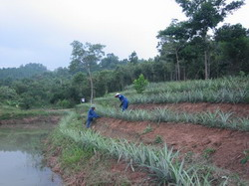
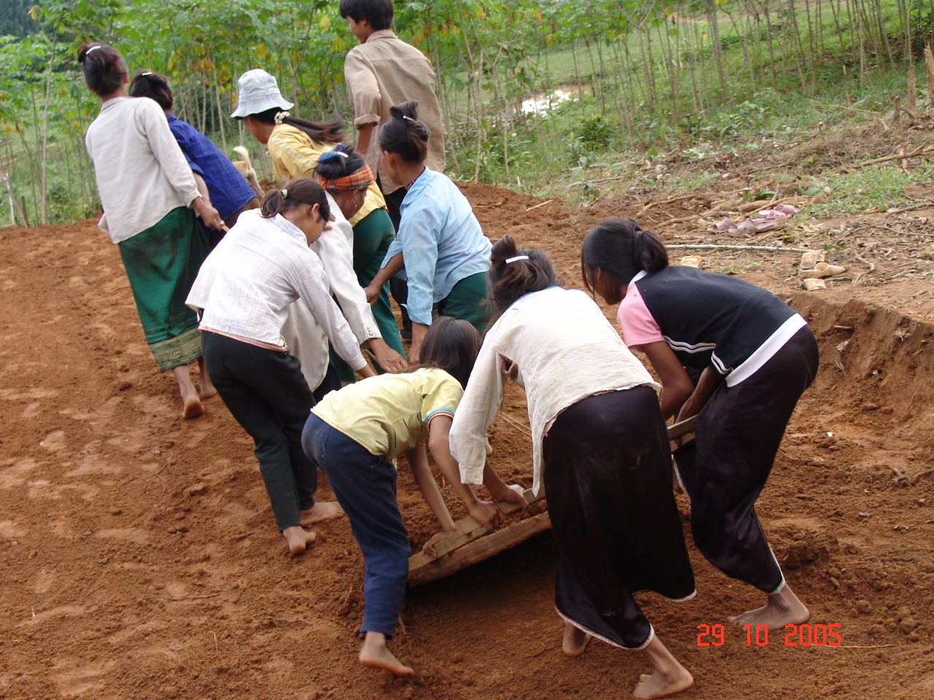
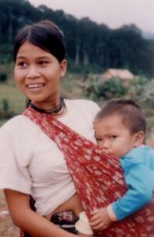
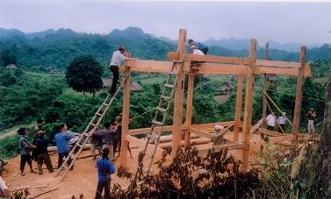
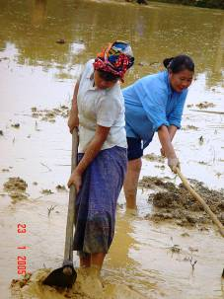

Abbreviations

CCCD Centre for Community Capacity Development, belonging to CIRD, located in Dong Le town, Tuyen Hoa district, Quang Binh province
CIRD Centre for Indigenous Knowledge Research and Development
Elders’ council A traditional leadership organ, set up in Ke village, including respected elders and clan leaders, who give advice for objectives, strategies and coordinate community development activities
FFS Farmer Field School, new form of CCCD in SPERI system
HEPA Human Ecology Preservation Area, in Huong Son district, Ha Tinh province
MECO-ECO-TRA Mekong Community Networking and Ecological Trading
Ngoi hoa Ma Lieng Traditional House Style programme, which combines preservation, promotion of Ma Lieng cultural values with improvement of housing condition
SPERI Social Policy Ecology Institute

The period from July 2007 to June 2008 was the time for SPERI’s holistic reform in terms of organization and approach for supporting target groups. Therefore, SPERI activities focused on support and advice to Ma Lieng network, so that they proactively carry out activities in this period. SPERI created opportunities for network members to meet and share experiences to stimulate activities at different villages according to the network plan.
Background
SPERI’s role has changed as inputs from collaborators and coordinators from the target community have grown. These Collaborators and Coordinators form a valuable link between SPERI and the target community. Continuously, the role of collaborators is shifting to Ma Lieng network. SPERI staff and collaborators only provide technical support with methodology, which is unable to be carried out by the network, such as training on savings and credit, husbandry techniques, garden planning, nursery. Although role replacement and new approach is not yet optimal, importantly, Ma Lieng people are being familiarized with a reduced reliance on outside support.
Besides this, SPERI started training for improvement of human resources of Ma Lieng community in 2007. There were 12 youth trainees of the age between 14 and 17. They participated in training courses on organic agriculture at CCCD and HEPA. After the training course, they applied techniques well at their household gardens and villages. 5 youths participate actively in community activities at Ca Xen village while 2 girls are now involved in local management of savings and credit activities. Trainees supported other villagers to set up and take care of village acacia nursery.
SPERI started decentralization of CCCD self-management, self-responsibility to a group of key-farmers in Quang Binh. SPERI and three key-farmers signed a contract to transfer 14.42 hectares land, including forest, systematic planned sloping land and terraces, fish pond, breeding facilities and houses at CCCD . The key-farmers set up a plan to apply sustainable agricultural techniques, focused on land enrichment and preventing from soil erosion.
Transfering CCCD for key-farmers’ self-management and self-responsibility is an essential step to change CCCD from research and experiment model to productive model of self-sufficient, self-financed farmers. This meets the needs of target community, who want to manage and develop CCCD as the first organic farming model in the area. Their high quality organic products contribute to gradually building up the MECO-ECOTRA image and trademark. However, many difficulties and shortcomings appeared during the first year of the new approach and decentralizing contract. On the other hand, new active trend open new development opportunities (This will be analysed in detail in the next sections).
This report evaluates thematic activities in Quang Binh province, such as Ma Lieng network, sustainable agriculture, farmer field school (CCCD), outcomes and impacts to local people and authorities.
Main activities in Quang Binh in this period
- Advise, support Ma Lieng network leaders;
- Technical support for some community development activities in Ke and Ca Xen villages;
- Training for 12 Ma Lieng youths;
- Transfer CCCD to some key-farmers, so that they take self-responsibility, self-finance;
- Monitoring of savings and credit of Quang Binh key-farmer network and set up plan, schedule for their repayment.

OBJECTIVES OF THIS PERIOD
- Ma Lieng network leaders actively and confidently set up and implement a network plan for community development at different villages.
- Development of a pilot, model organic farm by key-farmers, to serve as a demonstration site; a site for sharing lessons related to sustainable management of land, forest and water resources based on local cultural values encompassing organic farming methods.
Specific objectives
- Strengthen elders’ council of Ke village in organization, management, monitoring, planning for community development and their capacity for recognizing and solving problems arising within their community.
- Enhance Ma Lieng network leaders’ capacity through discussion, planning and monitoring meetings. Encouraging exchange between different villages and sharing between Ke elders and others.
- The capable trained Ma Lieng youths are involved confidently in organizing, managing and supporting community development activities at their Ma Lieng villages.
- CCCD is operated by key-farmers aiming at permaculture. Among other things, they apply compost, use terraces, banana circles, bio-gas, integrated animal raising and worm farming, to care for and enrich soil and attain a stable income.

Approach of the Quang Binh program is mainly for:
- Through meeting of the network to cooperate with Ma Lieng network leaders, then the network leaders implement their plan at their villages with support from SPERI staff.
Approach
- Maximize self-management role of the community interest groups, offer them environment for discussion and decision on community work. Accommodation improvement of Ke village decrease financial support, such as leveling ground or transporting tiles during this period. The number of carpentry collaborators was cut down from five to two persons. Two carpenters - Mr. Bui Huy Binh and Dau Hanh Cai support Ke villagers technically to finish the last of 35 houses according to plan at the end of 2007. Internal resources of Ma Lieng community are maximized together with Tuyen Hoa district leaders support to Ngoi hoa activities. In 2008, only one carpenter (Mr. Dau Hanh Cai) was needed to give technical support to the Ngoi hoa village capentry team.
- Due to changes of development approach and unfavorable weather conditions, 2007 saw some crop and animal raising poorly maintained and developed in Ke village. There was some community concern for those activities again in 2008. Therefore some collaborators of Quang Binh key-farmer network (esp. Ms. Nguyen Thi Hoa) returned to support agricultural, nursery, savings and credit activities. Presently, Ma Lieng community self-decide which activities they will invest in and develop..
- Give advice to Ma Lieng network through the role of network leaders: Mr. Cao Dung (Ke village), Ms. Pham Thi Lam (Cao village), Mr. Cao Hung (Ca Xen village), to inspire villagers to care for their crops, animals and household gardens. The network leaders organize a meeting every three months to exchange experiences between different villages.
- Encourage youths who have been trained in permaculture at HEPA, to become involved in such community activities as savings and credit, nursery, develop household gardens in Ca Xen village.
- Cooperate with authorities of Lam Hoa and Thanh Hoa communes to support implementation of government programme 135 and 134 for the sake of the community.
- After transfer CCCD, contracting key-farmers take self-finance and self-responsibility to decide on their investment and production. SPERI staff update development event and link the key-farmers to other partners if they need.
Priorities in Quang Binh
- Capacity building for 11 key-persons of Ma Lieng network, so that they confidently discover constraints, needs from villagers, to discuss and find out solutions. They are simultaneously offered chances for exchanging experiences and values of the Ma Lieng, so that to stimulate their internal strengths for community development.
- Give advice to Ke elders’ council to organize and coordinate final Ngoi hoa activities.
- Training for youths, who are enthusiastic and interested in permaculture and management. Create opportunities for those youths to be involved in interest group activities which enable them to successfully develop organic farming practice, and in the future take the role of management and implementation of Ma Lieng network.
- Support Ma Lieng women groups to set up revolving savings and credit groups. Help them with habits for savings and management of credit effectively.
- Complete Ngoi hoa programme in Ke village according to community and SPERI plans and cooperation with district authority.
- Transfer CCCD to key-farmers according to contract, which was observed by local authorities.

MA LIENG NETWORK ACTIVITIES
Main Activities and Results
In this period, SPERI supported a strengthened internal capacity of the network, so that they can manage and carry out gardening, animal husbandry and other community activities themselves. The network is interested in building up models of VAC (Integrated garden, fish pond, animal husbandry systems), so that to create stable income for households and community as a whole.
As a change of approach, SPERI focused on training of permaculture for selected Ma Lieng youths at CCCD Dong Le, and then at FFS-HEPA. Permaculture techniques at HEPA and returned to their village to apply permaculture, integrated with their traditional practices, in their own garden. Therefore, development activities in Ke village were mostly supported by two collaborators (Mr. Bui Huy Binh and Dau Hanh Cai) during this period.
SPERI staff cooperated with district development programme staff to continue Ngoi hoa work. This was combined with work to strengthen the capacity of the Ma Lieng network, including development of revolving savings and credit and investment for raising chickens and, pigs. District development programme staffs are new to Ma Lieng community while the Kinh key-farmer network is familiar to the villagers already. New interest groups were set up and now meet. These include savings and credit and gardening in Ca Xen village, and animal husbandry in Ke village. As members of interest groups, villagers get more attention and investment for their own garden and livestock. Importantly, Ma Lieng initially has been introduced to the concept of to savings and credit, which did not exist in their mind before.

Specific activities
Give advice for the network to set up and carry out plans
SPERI staff worked with Ma Lieng network leaders to organize network meetings to discuss exchange and monitor community activities at different villages. There were three network meetings organized in the first half of 2008 for setting up plans at different villages and that of the whole network. The participants also exchange community activities of animal husbandry, gardening, crops of their villages and finding ways of cooperating and supporting each other. The network members combined those plans with local agricultural production plans, these stimulated and organized villagers to complete essential crop calendar activities on time.
The network members and leaders found difficulties in exchanging new techniques of gardening and husbandry. Therefore, they focused on topics of methodology and decision making, weighing the pros and cons of each proposed activity and then crating a plan. This planning phase has been well thought through and is why, as yet, the network have not influenced much change to agricultural and husbandry activities in Ma Lieng villages.
Advice and support interest groups to develop household production
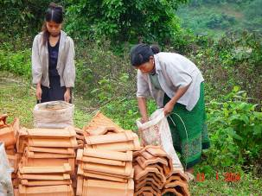
SPERI focused around advisory and support activities of the animal husbandry group of Ke village, the savings and credit group of Ca Xen village and the set up of a gardening group of 7 members in Ca Xen in the beginning of 2008. The following is a summary of those activities:
- An Animal Husbandry group was set up in Ke village in 2004, which consisted of 11 members, and then 11 other members joined the group since 2005 so far. This group carried out and finished 3 cycles of savings and transferring credit to members. Some livestock facilities were degraded, and the owners did not want to continue to invest in animal husbandry, while some others suffered from the poor conditions of 2007. The leaders of the group neglected to check and support members during that time, so animals died or did not reproduce except in some individual households.
Credit for husbandry group was calculated on April 30th, 2008 as follows (in Vietnamese Dong):
- Credit for first time for 11 members: 3,732,000
- Credit for second time for 19 members: 4,736,000
- Third time credit for 15 members: 9,961,800
Total 3 times for 44 rounds of members: 18,429,800
Payment: 3,045,000
Unpaid credit: 15,384,800
Opinions of some Ke husbandry group members
Mr. Cao Dung, at the monitoring meeting:
Every villager used credit for effectively raising pigs, some get high, some low profit, some sell the previous pigs and buy new piglets to continue raising. Those good pig raisers are: households of Ms. Lan, Mr. Phinh, Mr. Ky, Ms. Khai. Unfortunately, many pigs died in winter of 2007. There was not timly support of local vets, so husbandry was interrupted, villagers have not yet recovered because piglet price is so high nowadays.
We discuss here to find specific solution to continue husbandry. We should not forget support from CIRD in terms of techniques and piglets. Now we know how to raise pigs, so we self-consciously continue pig raising so that to improve our household income. Otherwise we have to pay back credit to CIRD.
Ms. Khai:
I like raising pigs, because it creates benefits. However, because of shortage of vets, we suffered from risk while pigs got sick and died, so we have to deal with loan.
Ms. Lan:
Whoever can continue pig raising, please go ahead. CIRD stimulated us to start and maintain husbandry already. We are facing high price of piglet recently. Piglets, which are sold by free traders are not so good, they often get sick. However, some households get good income from pig raising to have spare money for purchasing family equipment, such as household of Mr. Phinh and Mr. Dien.
Ms. Ngoan’s idea:
Raising pigs becomes more difficult nowadays, because piglet is expensive, pigs often get sick, then we may suffer from risk because of shortage of vets. We need more support for veterinary improvement.
Mr. Phinh’s opinion:
I raised two pigs and sold them to get more than VND 1 million, and then I bought a cow of VND 2 million. Nowadays my cow obtains a worth of VND 4 million. Recently I have no money. I plan to get some from forest, then I will continue pig raising and pay back CIRD.
Mr. Cao Dung conclusion:
Your discussion is interesting. Whoever wants to continue pig raising, please go ahead. We ask Mr. Truong for his assistance of buying piglets.

- Agricultural development
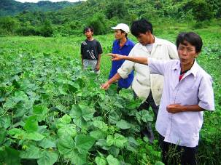
SPERI staff and collaborators assist villagers with advice and techniques, link them with local authorities to promote agriculture and animal husbandry and repair fresh water systems. Cold weather badly affected crops and animals at the end of 2007. The whole wet rice was destroyed. According to the network plan and suggestions, two SPERI staff (Chau Van Hue and Bui Hong Truong) and elder Cao Dung, worked with Lam Hoa communal authorities for their support seeds to villagers, so that they can seed again and recover their rice. That resulted in stable yield of Spring-Summer crop and ensured food for villagers.
- Support revolving savings and credit groups:
Revolving fund of Lam Hoa, which was set up from different revolving savings groups since 2003 commune is strengthened during this period. Two savings groups of Ma Lieng newly integrated in the communal fund: Ke village group joined since October 2007 while Cao group since 2008.
The collaborator assisted management board to complete balance and calculation of all savings and credit data so far, then instruct management board members to reset and maintain book keeping for their activities. Special attention was paid to Ma Lieng group.
Local authorities recommended enhancing monitoring, supporting savings and credit fund, and transfer credit fund from Kinh women to the Ma Lieng, so that they would get more fund for investment in husbandry and cultivation. Recently 38 out of 76 Ma Lieng women joined savings and credit fund, with their total savings of approximately VND 3 millions. Ma Lieng women get a total credit of VND 3 million out of the whole fund’s VND 17 million. Some Ma Lieng women have repaid the loan.
As participation of Ma Lieng women, Kinh people improve their view towards Ma Lieng capacity, especially that of the women. This is also an approach to enhance capacity and confidence of Ma Lieng women. Therefore, the programme should continue support Ma Lieng women to participate further in savings and credit activities, so that they will get more opportunities to share experiences and obtain habit of savings and responsibility to credit utility. Advise and assist management board to transfer credit fund from Kinh women to Ma Lieng is necessary to promote Ma Lieng’s investment for cultivation, gardens and animal husbandry. That will also contribute to improvement of the Ma Lieng capacity to manage investment for increased sustainable production, aiming at improved, holistic quality of life.
- Support revolving savings group of Ca Xen village
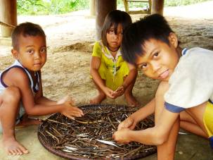
A study of Ca Xen village in April 2008 showed that villagers need to share and help mutually for development. With Thanh Hoa communal authorities’ support, SPERI staff and collaborators facilitated a discussion on savings, its benefit, and methodology for group foundation and operation. The participants understood well that a savings group would create chances for women to manage investment in cultivation and husbandry effectively. It will also create a good environment for women to practice management, organizational and operational skills for a community group.
The savings and credit group of Ca Xen village was built based on the principles of a simple revolving savings group. This group followed steps of setting up a savings and credit operation, i.e. strengthening group management and household economic management skills first, and then offering women credit, which can grow from small to larger scale. Recently two groups consisting of 15 members each were set up with active operation. They agree to follow these regulations:
- Monthly savings of VND 10,000 per person;
- Monthly group meeting on 4th of the month;
- Mutual help for construction of animal facilities;
- Jointly Monitor and supervise investment in husbandry;
- Sharing with each other on how to use credit.

Main topics for group activities are:
- Members share their difficulties and suggest management board, village leaders, and local officials for outside support when there is the need.
- Discussion of techniques and planning around the building up of animal facilities, and the use of credit for this purpose,
- Regular credit investment check on 20th every month.
Though women only receive a small fund of VND 70,000 to 100,000 from the group, they could get a good result from combining that fund with their own to raise three to five chickens. More importantly, they gain more community spirit, as every group member comes to help a member who newly receives a fund to build up or improve animal facilities. Mutual help and solidarity of the group and community thereby enhanced.
- Advice for planning of garden and vegetable garden
This was a central follow up activity of the SPERI training course on permaculture and slope land cultivation for Ma Lieng at the beginning of 2007. The first training was help at HEPA in April 2006. Although development of household gardens was not so active, the term of permaculture, organic farming and slope land cultivation were discussed and understood well by Ma Lieng key-persons. Two thirds of Ke households completed a plan and set up their garden, while 10% of the households integrated diverse trees and other crops into their garden.
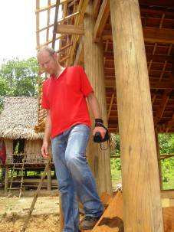
During the first six months of 2008, SPERI staff and collaborators focused on applying covering mulch for such crops as potato, bean, cassava, maize, taro, banana, ginger, saffron, pumpkin, calabash (as in the garden models of Mr. Ho Phinh, Ms. Cao Thi Khai, elder Cao Ngu, elder Cao Hai). Most villagers still practice free seeding and plantation without systematic planning. Besides they are not used to caring for crops regularly after seeding/ planting. This shift has only become commonplace in the community of Ma Lieng, which only transfer from shifting cultivation to stable gardening recently.
Therefore basic simple techniques of permaculture, such as household vegetable gardening, covering mulch, and integrated crops were introduced and discussed during this period. Villagers need enough time to observe and practice, then build up their willingness and habit. Key-persons and HEPA-trained youths would be the first applicants to share and help other villagers to apply. On the other hand, interest group of gardening should be gradually developed. That creates foundation for further multiple of permaculture garden in Ma Lieng community, which can subsist organic products. That is also difficulty when applying Permaculture
Training youths on permaculture
SPERI organized a training course for 14 Ma Lieng youths at FFS Dong Le and HEPA for six months at the end of 2007. After the training, those youths went back to apply at their garden and community. Evaluation showed that, the youths want to continue with refresher and advanced training and practice of permaculture, so that they can work better at their community.
Five trained youths of Ca Xen village participated actively in community activities, such as household gardening , and became involved in the gardening interest group. Three female youths are now involved in savings and credit and help each other in animal husbandry activities.
Two trained youths of Ke village, Ho Van Phong and Ho Khuyen, work well at the village, they hope to become key-persons for community development activities. After receiving grapefruit and orange seeds, Khuyen applied lessons and training techniques of digging holes and planting trees to other villagers and communal officers in January 2008. Communal officers commented that, Khuyen had applied techniques well; other villagers should be inspired and motivated to follow him.
Three trained youths from Chuoi village have not shown good practice in comparison to others. They spent a lot of time going to the forest to collect products and some time for caring for garden, rice, other crops and some other community works.

Comment of elders, village leaders, and communal staff
Mr. Pham Hanh (Chuoi village head) said: though three trained youths in my village did not their garden as well as others in other villages, they got more skills in caring for vegetable, setting up trellis for calabash, pumpkin. Communal officers appreciated their participation in community works, such as performance and sport. This is the first time Chuoi villagers gain such a good appreciation from their community activities.
Elder Cao Chau of Ca Xen village said: Right after coming back, the trained youths worked actively with their garden models, so that to reflect and report results from the training course. However they could not maintain enthusiasm for long because they face day-by-day existence and need to assist their parents. Shortage of checking and help from trainers may be additional reason.
Mr. Le Hong Thi, Thanh Hoa communal officer said: Hearing from trained youths and SPERI staff, I understood that the training course was meticulous. They showed their first good results of technical application. Their style of work and behavior are especially improved. With such a short training time, it is worthy to appreciate those changes. Community should pay more attention, participation and support, so that those youths can apply lessons more effectively.
Ke elder Cao Dung’s idea: After training course, the youths could not set up and develop their garden models consistently. That is others’ shortcomings (myself, Mr. Truong, trainers, elders), not the youths’ faults. The youth faced difficulties while applying at the field without regular check and help. However, those youths got much better in terms of work style, behavior, plan and action. I suggest early follow-up training course, otherwise interruption is so long. As learning more is better, without CIRD and Ms. Luu’s training, how can Phinh, Doi and Hoai work well today? Without a lot of training courses and practice, how can Ma Lieng people deal with wet rice and result in such nice gardens as those of elder Hai, Mr. Ky, Ms. Khai, Mr. Phinh in Ke village and such good planning and calculating farmers as Mr. Vien, Mr. Bot in Ca Xen village?.

Complete Ngoi hoa programme in cooperation with Tuyen Hoa leaders
Villagers faced more difficulties due to the change of support approach and reduction of financial support since March 2007. Villagers made great efforts and achievement previously; however they could not confidently gain all necessary skills in such a short time. The number of Ke households increased from 30 in the year 2000 to 42 in 2007, which challenges the coordination capacity of elders’ council and Mr. Cao Dung. The villagers change from mutual support from the whole village to support amongst a group of households, of which the family, who receive house building support, should be the core responsible person with technical support from carpentry team and two collaborators (Mr. Bui Huy Binh, Mr. Dau Hanh Cai).
Carpentry team includes: Mr. Cao Ngu, elder and leader of the team. Other youths are: Cao Son vice leader of carpentry team; Cao Tam - carpentry team member; Cao Doi - carpentry team member; Cao Tinh - carpentry team member.
Diagram 1: An example of organization for making house of Cao Thuy

Cao Thuy
Cao Xom - Thuy’s younger brother
Cao Le Thuy’s elder brother
Cao Lach -Thuy’s wife’s brother
Cao De - Thuy’s elder brother
Cao Hung - neighbor
Cao Hoa -Thuy’s brother-in-law

Whenever the family needs more labor for tile transportation, ground leveling, road building for transporting wood, they would inform the elders’ council and village leader for help. Entire households of the village are expected to participate in every house setting up in a rapid and safe manner nowadays. They share green tea, and some wine with food after work. Due to daily work for existence, less people are involved in house building but those involved are more professional in skills and organization in comparison to the past.
SPERI supported the completion of 35 houses in 2008 according to Ngoi hoa development programme and with the commitment of the local authority. However, during Ngoi hoa process, six new households appeared as a result of household splitting or removal to Ke from Chuoi village. The Elders’ council discussed for resolution for two households of single. Mr. Cao Nhung is allowed to live and care for garden at community house area while Mr. Cao Tam live with his son’s household. The remaining four households (Cao Son, Cao Tinh, Cao Nuoi, Cao Thanh), who have not received support to build suitable houses have also contributed a lot to the Ngoi hoa programme. Therefore, villagers decisively tried their best to continue and finish. However they may face many difficulties if there is not further support.
In that situation, SPERI staff discussed with Tuyen Hoa district leaders to gain an additional financial support and apply the Ngoi hoa approach of decentralized community management and operation:
- Elders’ council calculates and decides on suitable use of financial sources. They stimulate villagers to level ground, build road for wood transportation, transport tile to building site. The house owners work by themselves to collect wood for the house floor and house cladding. Additional financial support merely deals with purchasing tiles, nails, and a part of rice for carpentry work.

- SPERI further supports collaborators, offering necessary carpentry techniques and stimulating villagers to build houses, and make good purchases of necessary materials.

Diagram 2: Contributions for Ngoi Hoa program in Ke village

Total expenditure for a house is VND 50 million
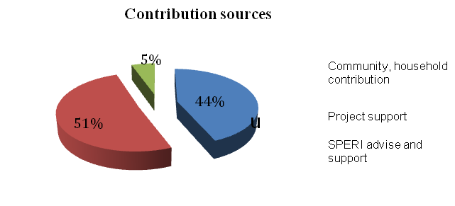
Evaluation of activities in Ma Lieng community
Self-responsibility, self-control by Ma Lieng people
The Ma Lieng network brought several changes to Ma Lieng community according to the objectives of the development programme, i.e. to enhance effective community activities and to create chances for exchange and mutual help. Ke village is a pilot model, aimed at maintaining and promoting Ma Lieng cultural values, A model which when successful could be applied and developed in other villages. The network must contend with a shortage of transportation coupled with a large area. It takes a long time to walk from village to village. At the beginning of the project, they faced a stark shortage of skills for planning and operation of the network. However they they shared what they knew, and have achieved results through supporting each other.
Recently a leadership board for the network has formed. However, their working dimension still does not go beyond the bounds of stimulating a link throughout Ma Lieng. There is now even greater potential to effect positive change and continuous effects and impacts to Ma Lieng villagers. Mr. Cao Dung, Ke village head said: “though network itself is meaningful, community activities are not continuous and highly effective because villagers have to deal with food and daily life. Therefore, they cannot maximize their participation and contribution to the network. Additional local and project support would be needed to foster the progress.
The Ma Lieng helps each other to run their own community events or ceremonies, such as wedding, house building, and funeral. According to them, going to help each other that way is one of the ‘networking activities’ already. They maintain traditional sharing and mutual support especially in cases of unexpected difficulty or hunger.
Network self-control
- Network leaders plan, suggest and organize every meeting and discussion during this periold. SPERI staffs merely help them with methodology, communication and transport means.
- Network leaders combine network meeting and discussion results to share at village meetings or discuss with communal officers.
- Network activities made relationship amongst Ma Lieng stronger. In the past, some Ma Lieng youths disagreed with each other when one from this village come to visit others. That is resolved and restricted nowadays as results of the network solutions come into action.
- Network members voluntarily work with each other for the network without any outside support. There are remarkable results since the network establishment:
  - Ca Xen villagers worked with and shared experiences of wet rice cultivation to Ke villagers. Ke villagers helped Cao and Chuoi villagers with ploughing and Cao villagers leveled ground and transport tiles for Ke villagers. Ke villagers helped Ca Xen to transport wood to build their community house.
  - Som Ca Xen villagers, such as Mr. Cao Lac, Cao Xuan have been involved in Ngoi hoa activities in Ke village several times. Each took five to seven days. Although those exchanges and mutual support integrate with local traditions, the activities are based on initiatives from the network planning.
Ma Lieng community view the network as a foundation for maintaining and enhancing Ma Lieng cultural values, so Ma Lieng people do not feel alone in their development. Mr. Cao Cuoi (Ke villager) said: “the Ma Lieng are different from others because we live inside forest and suffer from more difficulties. Our role should be as good as Kinh’s if we have community solidarity. If we try, with our best efforts, we will surely be better in the future”.
Decentralization in Ma Lieng development approach
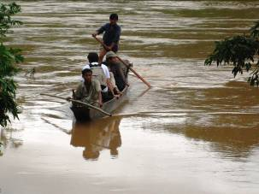
The Elders’ council found good candidates for the leading roles in the Ke Ngoi hoa programme since the foundation of the network. Voices from network members inspire villagers to join in community work. For instance, Ms. Lam (from Cao village) and elder Cao Chau (from Ca Xen village) inspired villagers while they were talking with Ke youths and women during their meeting. Then Ke villagers got increased dynamism towards the Ngoi hoa programme and competition for improvement of gardens and animal husbandry systems.
A lot of discussion and even disagreement appeared during the change of approach for Ngoi hoa. For instance, elder Cao Hai wanted to support building Mr. Cao Nuoi’s house first while elder Cao Ngu suggest priority to Cao Loi. The network leaders (Ms. Lam, elder Cao Dung and elder Cao Chau) explained Ngoi hoa systematic approach and pro-Ngoi hoa activities to those elders. They assure the elders of the success of the programme if all of them make an effort, the resulting agreement and solidarity for further strengthens the community today.
The network facilitated good resolutions for conflict when it arose within the community. For instance, Cao Tuan (Ca Xen villager) rode bicycle down the slope, then made accident to Ms. Dong (Chuoi villager). Local authorities found it difficult to deal with the case. With the help of network leaders (elder Cao Dung, Ms. Pham Thi Lam, elder Cao Chau), authorities from two communes of Lam Hoa and Thanh Hoa and two related villages entered discussion, ultimately finding a suitable solution. Authorities of the two related communes appreciated the role of the network.
The network leaders contributed advice to select, prepare and organize the community for the FFS training course for 14 youths. At the time of selecting youths, Ke villagers wanted youths to complete Ngoi hoa first while other villages would wait to see the results from Ke village. Mr. Bui Hong Truong, SPERI collaborator discussed with network leaders, and they decided to organize a network meeting. There, they came to an agreement and decided to start the training course, SPERI staff then worked with local authorities for agreement. Communal officers recommended Mr. Ho Bot, Ho Van and Cao Chau (Ca Xen village), Mr. Cao Dung (Ke village), Mr. Pham Hanh (Chuoi village) to lead those youths to FFS Dong Le, to assist both youths and trainers to complete the training task. This case partly illustrates the valuable coordination role of the network, showcasing their systematic, suitable approach to community works.
Cooperation with local officers for supporting the network
Although there was not remarkable cooperation between the informal network and local officers, the local authorities recognized the existence and active role of the network. The local officers view the network as a good development trend for Ma Lieng community, to help villagers improve their quality of life in terms of social, cultural and economic aspects.
The network need SPERI support to increase opportunities for sharing and debate of Ma Lieng-related issues between villagers, network leaders and local officers, and to offer advice for better understanding the full capacity of the role and value of the network. Suggestions should be offered to local officers that, their cooperation in decentralizing decision making would promote the network leaders’ role leading to more effective development work. Successful development work will continue to contribute to local officers’ recognition of the actual political role of the network in the community and surrounds.

DECENTRALIZATION FOR SELF-CONTROL, SELF-RESPONSIBILITY OF KEY-FARMER NETWORK
SPERI decided to transfer self-management role over CCCD_Dong Le to Quang Binh key-farmer network on August 22nd 2007. They signed a contract, allowing the key-farmers to use CCCD areas for 15 years for permaculture, agro-forestry activities according to the following commitments and principles:
- Self-managment, self-responsible, self-finance.
- Caring for the nature, to maintain sustainable harmonious relation between humankind and the nature.
- Maintain community spirits and sharing for promotion of social capital for MECO-ECOTRA. In other words, key-farmers who receive CCCD are responsible to represent the network to nurture values of social entrepreneur, to use common resources for the sake of the common good.
After one year, three key-farmers (Mr. Hoang Phuoc from Lam Trach commune, Mr. Pham Dinh Mon from Dong Le town, Mr. Tran Dinh Minh from Lien Trach commune), faced several human and financial difficulties in their CCCD management. Two key-farmers (Mr. Phuoc and Minh) withdrew from the contract due to family reasons. Therefore only one key-farmer has continued his management and production on CCCD according to the contract since February 2008.
Though decentralization and transfer activities did not totally meet the expectation so far, this experiment creates a new approach to poverty reduction and more opportunities for contacts and cooperation between farmers for marketing of their products and building their image and trademark in the future.
Lessons from this decentralization approach
CCCD have taken up the functions of research and experimention of suitable trees and livestock. This work will lead to the development of training and networking about sustainable land use practices, with farmers. Alongside these functions, key-farmers face many teething difficulties while also sustaining their own finance, to produce and reinvest when CCCD is transferred to them:
- Ownership: Key-farmers have not maximized meanings of ownership and decision making at CCCD. They still focus on utilization of inherent infrastructure and components of CCCD and lack re-investment practices and development of different components. There is an apparent imbalance: husbandry is promoted while trees and gardens are neglected. It is a reasonable expecttion that, in a well planned permaculture agricultural system, all components (garden, husbandry, fish pond) should be adequately developed and able to support each other.
- Experiment and training functions: on site sub-model components for training purposes have degraded since previous years. These sub-models need labour investment and some resource investment before achieving a return income. As such, these functions may not be the first priority for a key-farmer self-management system.
Follow-up transferring CCCD
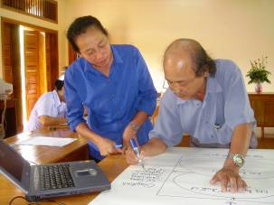
Because of the withdrawal of two key-farmers in 2008, CCCD faced more difficulties. Therefore, SPERI staff and coordinators carried out monitoring one year following the transfer of the CCCD in september 2008. The participants suggested three main tasks to suit the new situation of CCCD:
CCCD should promote research and experiment functions again, so that to improve quality of soil. Also, lessons learnt from permaculture and fighting against desertification should be documented.
- CCCD have obtained available training manual, learnt lessons, infrastructure to serve training, exchanging and research.
- Partially self-finance for management and development of CCCD through production and transferring of technology, training services, providing information, marketing organic products for key-farmer network.
- CCCD should change its approach to management to meet requirement of those three priorities. Some SPERI staff should take direct responsibility of organization and management of the following strategies:
- Develop science technology capacity of interdisciplinary to meet diversified and high requirement of farmers and farm owners.
- Strengthen information systems for agriculture and rural development, especially those produced by experienced experts.
- Set up information system of development of sustainable agro-forestry models, related science and technology, agricultural market and relevant laws and policies to meet farmers’ needs. Step by step set up Website of CCCD for updating and linkage CCCD to outsiders.
- Set up network of farm owners with safe organic products and introduce their products to the market. Set up community enterprise and transfer management and operation rights to farmers.
- Promote cooperation with research centres, institutes, donors in order to fulfil functions of CCCD.

SAVINGS AND CREDIT ACTIVITIES IN KINH ETHNIC GROUP
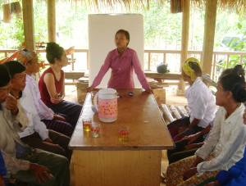
Since 1998, CIRD started to support interest groups of animal husbandry, gardening, savings and credit, herbal medicine, bee raising. CIRD support those interest groups to build up their capacity, regulations and trust amongst themselves, and between the group, the community and local authorities for the sake of community development.
Savings and credit groups create good opportunities for other interest groups to invest for production expansion, such as animal husbandry, gardening, fish or bee raising. Gender, savings and credit have become an important section of CIRD community development activities. Savings and credit activities aim at creating opportunities for ethnic women in remote areas to improve their household and community management skills and contribute to improve their income and livelihood as well.
So far six communes have set up communal savings and credit fund for a total of 1,300 members. Recently, total credit fund from CIRD is VND 1,250,350,000 and total savings from community is VND 527,785,000 while total inflation fund is VND 311,115,117.
The revolving fund meets the needs of local people, especially women, to invest in agricultural activities resulting in increased income. More importantly it creates a favorable environment where women are able to join group activities, to practice and improve their household, group and community management skills as well as practical production skills. After 10 years of operation, savings and credit activities face challenges from approach changes, which require higher self-responsibility, self-control of the group leaders for the sake of remote people and women.
Finishing a project phase or a credit cycle, which contain changes is a development sign. After 10 years of operation, revolving savings and credit fund in two districts (Tuyen Hoa and Minh Hoa) of Quang Binh province should be monitored for new strategy suggestions.
A savings and credit workshop held in July 2007, worked out objectives and orientation towards building savings and credit fund on the foundation of internal effort and strength from every network members. Therefore, the fund should be basically built on their own savings. Workshop participants set up a schedule for CIRD credit repayment for duration of three years (2008-2010), so that to remove credit from this community to the others, especially ethnic groups, who face more difficulty. It is expected that, repayment activities may be faced with difficulties, such as slow repayment action because some borrowers want to continue long investment (e.g. cow raising) and may require longer term loans.
After final efforts of Ngoi hoa programme, this programme activity has been completed while the elders’ council try to coordinate villagers to complete the last houses largely independently, with only minimal support from SPERI and local authorities in 2008. That illustrates the wonderful commitment and capacity of the elders’ council and Ke villagers in management and implementation of community works. This type of management and operation for such community work was rare before 2004.
Effective and Impacts
Training for Ma Lieng youths has resulted in initial active and practical impacts in the community. After training, the youths have increased their participation in positive community building activities. Cao Van Khuyen has created good results and products for Ke village, while Ca Xen trained youths set up and cared for a nursery. Local officers appreciate trained girls who effectively work on revolving savings activities. The youths in particular and Ma Lieng people gained further knowledge and recognize the values of household management, investment, savings, community management. This is a good foundation for Ma Lieng community development in the future.
Ke village changed a lot both in terms of intangible results (confidence, willingness for development) and tangible expression (houses, gardens). Local authorities appreciated CIRD (then SPERI) approach while other development programmes want to cooperate with community traditional leaders and CIRD for benefits of local people. As CIRD supported villagers with wet rice promotion, the local authority helped with an irrigation system; local authority helped villagers to make sewers while Ke villagers were building a new internal road. Lam Hoa communal officers invited SPERI staff to participate and contribute ideas for local development plan for Ma Lieng group. They worked with SPERI staff to support villagers to build 17 buffalo and cow sheds with the fund from Quang Binh Mountain and ethnic minority department. The carpentry team and SPERI carpentry collaborators helped some villagers to set up cow sheds in cases of difficulty and high needs.
Although CCCD has not yet reached the level of training and experiment needed for a really good demonstration site, its image and voice are gaining recognition by NGOs who deal with agricultural promotion. Some organizations, such as a delegation of NGOs, who are initiated by Quang Binh External Relation department, CRES-supported farmers from Quang Tri province, Rural Development Fund of Quang Ninh district, Quang Binh province (RDPR) visited and shared experiences during 2007-2008. PLAN staff visited and suggested cooperation for training, and Counterpart suggested CCCD to cooperate and help them to set up farming models in Bo Trach district. The potential to reach the expected model outcome is very tangible.
Farm managers of CCCD set up linkage to various farmers within and outside the key-farmer network. One farmer from Quang Trach district self-paid the training fee to learn bee keeping techniques, which is trained by CCCD farmer-managers at CCCD in 2007. Farmers of CCCD have exchanged experiences of raising pigeons with some farmers from Quang Trach district, shared techniques of bee keeping with Mr. Vinh from Kim Hoa commune, and fish raising experience exchange in Lien Trach commune. After sharing experiences, those farmers applied new techniques well in their own gardens.

Although Ma Lieng overall network did not impact strongly on agricultural production activities, they acted quite effectively for maintaining and promoting Ma Lieng cultural values (as described in the previous sections).
Challenges
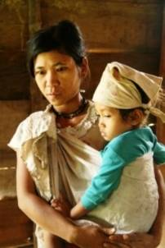
Ma Lieng network has been set up for three years; the members are now familiar with their own organization and approach. They have helped to bring changes to the community: Ma Lieng people preferred to collect forest products and received support from local authorities in the past. Recently they have been motivated and become familiar with setting up their own development plan and monitoring development activities. Their network leaders coordinate; organize network meetings and other community works. Though their self-management is not fully strong, the Ma Lieng has made great efforts to improve their ways of agricultural production and income to ensure their livelihood.
In such a short period, the Ma Lieng inevitably faces and solve difficulties in changing processes, because they have their inherent life style and vision. They were used to supporting between relatives and family lineage, however community management and mutual support between different villages is new approach for them.
Slope land traditional shifting cultivation used to belong to a family or an extended family, so management and operation is simpler for such a small scale. Nowadays they change to cultivate stably at a interaction large cultivation area with new wet rice cultivation, so they need time to get familiar with the new situation, as well as new relationships between Ma Lieng people, Ma Lieng and outsiders, between Ma Lieng and the nature. The Ma Lieng changed from subsistence economy to linkage to the market, so they feel unfamiliar with trading with outsiders and dealing with negative impacts of the market.
Implementation and approach of large development programmes for ethnic minorities initiated by the government caused side effects, such as the undermined trust of local people towards implementation staff. They may react negatively, even ignore outsiders, which causes difficulties to the network.
Some network leaders (Ms. Pham Thi Lam, Mr. Cao Dung, and elder Cao Chau) experienced project and local work participation for a long time, so they may influence development policy and activities at their localities. They contribute ideas, comment to every new introduced ethnic policies and programmes. Network activities encourage such members as Mr. Ho Bot and Ho Xuan (Ca Xen village), Mr. Ho Phinh (Ke village) to voice and strengthen their influencing role in the community. However, those network leaders need more opportunities to enhance their coordination, organizational skills and knowledge, skills of garden, husbandry, so that they will improve their quality of support to the Ma Lieng. It is reasonable to support those network leaders with methodology, techniques and seeds, so that they will be able to set up farming models of stable self-subsistence for exchanging and promoting in Ma Lieng community.
The network leaders need more time, rather than three years, and further involvement from Ma Lieng villagers, in order to make full use of their active coordination role. Therefore, it is necessary to continue support to the leaders and decentralize them to organize community development work at the community by themselves. Opportunities for exchanging and learning from other networks, other ethnic groups (e.g. Thai, Mong) and skillful key-farmers are important to speed up their confidence and capacity improvement.
Forest has been being exploited and exhausted, then forest-base villagers’ livelihood become more difficult. Therefore, they need help for broaden their wet rice, garden, crop cultivation area. On the other hand, it is possible to develop new jobs, which create new products of additional values to available forest materials, such as rattan, bamboo, hat leaves. This requires close cooperation between community, the network, SPERI and local authorities to aim at common benefits of the community.

Ma Lieng network
Recommendations
As in the analysis above, it is necessary to continue support to Ma Lieng community and the network in particular. Selecting suitable persons and train them to become new network leaders should be seen as a long-term strategy. Foundation of community organizations, interest groups will contribute to maintain and promote traditional values of the Ma Lieng. Therefore, continuous activities may be suggested as the followings:
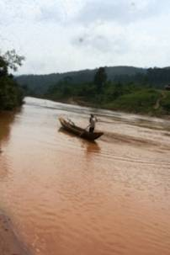
- Continue Ma Lieng youths’ approach of training and practice at their own gardens, set up and link different interest groups and set up other small groups for mutual support and exchanging labor.
- Continuous support to Ma Lieng network to organize, manage and operate community development activities at different villages. SPERI staff provides advice of development strategy and programmatic approach for the network.
- Additional technical support to pilot models of garden, husbandry. Step by step set up groups of gardening models, and diversify jobs (to promote rattan and wooden skills) in the community. That creates foundation for subsistence economy of the community, which help to minimize dependency and negative impacts from market and outsiders.
Continuous cooperation with other local ethnic mountainous development programmes is necessary, so that to create more development opportunities for the Ma Lieng. Training for youths should be considered high priority, particularly in the context of land and other natural resources become more and more scare. As integration process, Ma Lieng youths need more household economic management skills and non-farm extra jobs to improve their production and income.

Other activities in Quang Binh province
After ten years of operation, key-farmer network in six project communes of Kinh ethnic group in Quang Binh province attain several influences to local development activities. Many key-farmers have confidently involved in community management and local governance. They are recognized and appreciated by local officers thanks to their role and contribution. Contributions of key-farmers and coordinators of the network to research, support community development in Ke village (Ngoi hoa programme for Ma Lieng people) is remarkable.
Network initiatives and activities suit to local people’s needs and contribute to local sustainable development agenda and sustainable natural resource management as well. To gain those achievement, key-farmer network have to experience several upheaval development periods, sometimes they have to overcome crisis. However, with the pioneer role of coordinators, advice and support from community, local authorities, their network will be expectedly maintain and develop in the future.
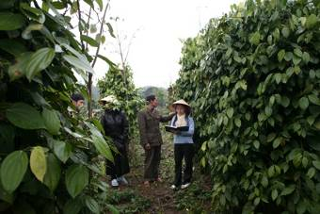
As changing approach and network reform during 2006-2008 period, all network coordinators came back their community to recover their own farms and direct support local interest group activities. Recently they keep and develop network linkage in a new simple form. This is not suitable time for them to upgrade those linking interest groups to become fully legalized community organizations in this context. Challenge of poverty reduction and community development still exist in remote areas, so it is suitable to continue CIRD’s role in community development in Quang Binh province. Additional specific reasons are:
Key-farmer network may take more active role in supporting community development for other ethnic minority groups. Ma Lieng network is the first ethnic minority network, which was set up to carry out approach for Ma Lieng development. Other ethnic groups need further exchanging, mutual help, so that they will be stronger together to deal with new challenges caused by market, integration and globalization.
CIRD will meet the needs of providing science and technology services, linkage with other NGOs, state and development programmes for the common target, i.e. benefit of poor people.
Enhance CCCD functions as research, experiment, and practical training model. This will become a good point for linkage between different NGOs, CBOs, and local state agencies. CIRD operation will support CCCD to create more opportunities for local people, officers, the media and intellectuals to join various forum, study visit and debate for better vision and suitable approach to community development.

- The collaborators consist of: 1 one member of key-farmer network (Ms. Nguyen Thi Hoa, coordinator of Kim Hoa commune); Mr. Bui Hong Truong, coordinator for Ngoi hoa (accommodation improvement) at Ke village.
Network leaders consist of three members: Cao Dung, Pham Thi Lam, Cao The Hung. The network focus on the following topics: - Sharing and discovering needs for the plan of the network and each Ma Lieng villages. - Sharing experiences of organizing, managing, coordinating agricultural activities and community works. - Exchanging traditional values of Ma Lieng, which appear and enhance within community activities for maintenance and strengthening of their cultural values
Ngoi hoa (housing style improvement) in Ke village was implemented according to development programme from 2003 to 2007, of which 35 Ma Lieng houses will be supported to build, in order to preserve cultural values of the Ma Lieng. Traditional customs, ceremonies, norms would be recovered during Ngoi hoa activities, so that every person, especially youths, further understand pride in their own identity and confidently maintain their culture through daily practices, including their housing style. Ngoi hoa also helps Ma Lieng to adapt to new working environment, to plan, manage, carry out, monitor and adjust their community activities. Because of the increased number of households, SPERI staff worked with Tuyen Hoa district authorities to get more support from them, in order to finish the houses. These Ngoi hoa activities were combined with other activities, such as gardening, nursery, savings and credit in Ke and other villages.
Including trained youths: Ho Thi Lan, Ho Thi Lam, Ho Thi Long, Ho Van Dinh, Ho Van Khinh.
FFS-HEPA: Farmer field school at HEPA-Human Ecology Preservation Area in Huong Son, Ha Tinh provice.
Programmes 135 and 134 are set up and implemented as the government programmes for the most difficult communes, mostly remote and ethnic groups. They focus on infrastructure, supporting seeds for development of those poor areas. Than Hoa and Lam Hoa communes belongs to the area of 134 and 135 programmes, so it is needed to cooperate with those programme, so that to maximize their investment resources in an effective way and minimize side effect and help to improve their approach to community.
Including Mr. Cao Dụng, Ho Phinh, Ho Ba of Ke village; Cao Ai, Nguyen Thi Nga of Chuoi village, Pham Thi Lam, Cao Thi Dung, Ho Thong of Cao village of Lam Hoa commune; Cao The Hung, Ho Bot, Cao Chau of Ca Xen village, Thanh Hoa commune.
Ngoi hoa programme was divided into 3 main phases of approach, with reduction of outside support and increase of internal community contribution. The first phase started in October 2003 to beginning of 2006, finished 29 houses; Second phase finished 30th to 35th houses, from the end of 2006 to the end of 2007; third phase finished 36th to 40th houses in 2008.
Including Mr. Hồ Thông, Hồ Đàn, Ho Thi Long, Hồ Kim, Hồ Bợt, Ho Van, Hồ Xuân.
Every household collects wood and other materials themselves, then other group members or their family members will help with carpentry and setting up the cages or stables. Other local technicians may combine this group activity with training on the method to select suitable place for cages, stables or make hole to prepare for tree plantation, or planning of vegetable garden, etc. The villagers gain more opportunity to share and learn each other to set up household or clan, or a group’s plan. Therefore, community spirit is strengthened with this way of working.
Out of 11 trained youths, three youths (Ho Van Dinh, Ho Van Khinh, Ho Van Phong) applied banana circle and water garbage treatment ; seven of them (Ho Thi Lan, Ho Thi Lam, Ho Thi Long, Ho Van Dinh, Ho Van Khinh, Ho Van Phong, Cao Van Khuyen) applied compost and plant vegetables, orange, elephant grass for feeding cattles.
They are three Ma Lieng youths, who were trained at CCCD (FFS) Dong Le during 2000-2004.
Tile transportation on the distance of 1,000 meters, across a river
CCCD: Centre for Community capacity development.
Six communes are: Xuan Trach, Lam Trach, Lien Trach of Bo Trach district, Kim Hoa, Cao Quang and Ngu Hoa of Tuyen Hoa district.

