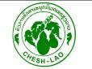
Yearly Narrative Report
Jul, 2007 - Jun 2008
CENTER FOR HUMAN ECOLOGY STUDIES OF HIGHLANDS (CHESH) - CHESH LAO PROGRAM
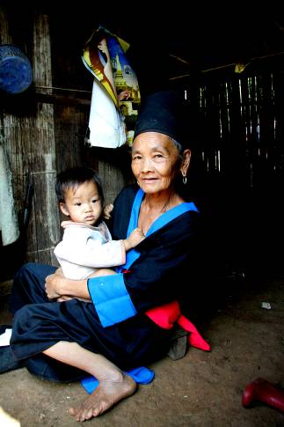

Index

 | Content | Page
 | Information of the project | 3
 | Background | 5
 | Achieved Indicators | 6
 | Approach analysis | 16
 | Lessons learnt | 18
 | Partners of CHESH Lao Program | 21
 | Challenge analysis | 22
 | Case studies | 23
 | Reference | 24

CHESH Program in Laos

Project name: Customary Laws Network in NRM in the watershed (Period 2006-2009)
Project number:
Reporting period: From July 2007 to June 2008
Place: Luang Prabang and Nam Bac districts, Luang Prabang province, Laos P.D.R

ManagIng agency: Center for Human Ecology Studies of Highlands - CHESH
Address : A4, Ngoc Khanh science village, Dong Da district, Hanoi, Vietnam
Ph. : 84-437715690
Fax : 84-437715691
E-mail: dttuan@speri.org
Contact person: Mr. Dam Trong Tuan, acting director

Implementing Agency:CHESH Program in Laos
Address: Pha Bat village, Luang Prabang district, Luang Prabang province, Laos
Telephone: (856-71) 254 461
Fax: (856-71) 260 271
Email: chesh-lao@gmail.com
Contact Person: Mr. Somphong Pradichit, director of PAFO

Acronyms

CHESH: Center for Human Ecology Studies of Highlands
NRM: Natural Resource Management
LVTHEN: Lao-Viet Traditional Cultural Herbal Network
LVTHAN: Lao-Viet Traditional Handicraft Textile
MAF: Ministry of Agriculture and Forestry
PAFO: Luang Prabang Provincial Agro-Forestry Office
DAFO: District Agro-Forestry Office

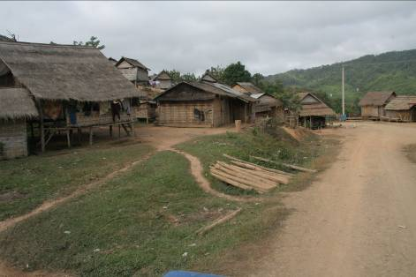
The previous phases of CHESH Lao program (2000 to 2002 and 2003 to 2005) have sucessfully advised to establish thematic networks at three villages of Long Lan, Xieng Da and Nam Kha of Luang Prabang province, Laos. Thematic networks organize, implement and monitor community activities in an active, creative, confident manner. Moreover, the programme activities have been positively influencing local authorities and provincial, district professional staffs.
Background
CHESH Lao program focuses on customary laws network and indigenous knowledge of natural resource management (NRM) in the watershed of Luang Prabang in the period from 2006 to 2009. Different forums were created for the diverse linkage of voluntary common strengths of concerns and interests. That is seen as a foundation for democratic creative space for everybody’s and community’s rights in the process of decentralization in NRM.
The network tried to gather strengths and potentials of every community, so that to restrict challenges from the market, to ensure people’s rigths for their customary laws and resources.
During this report period, Luang Prabang people in general and villagers of three project villages were deeply impacted by mono crop (coffee, rubber) policy. Private companies and individuals, who have available money tried to buy land for cash crop plantation. Therefore, they push great impacts on community traditional values of watershed resources management and protection.
This report would analyse community’s role, particularly that of networks of customary laws, herbal, handicraft, sustainable agriculture through decentralization strategy and the active role of CHESH Lao to react to challenges and impacts of the policy.

The program’s yearly objectives are to:
- Strengthen Hmong of Long Lan and Lao Lum of Xieng Da traditional customary laws for NRM, community management and democratic administration.
- Strengthen the herbalist network, so called Lao-Viet Traditional Cultural Herbal Network (LVTHEN) within and between different ethnic groups (Hmong, Khmu and Lao Lum), and ethnic groups in Vietnam.
- Strengthen handicraft network namely Lao-Viet Traditional Handicraft Textile (LVTHAN) within three mentioned villages and between different ethnic groups of the network in Laos and Vietnam.
- Approach to the pilot model of fair trade for organic vegetables of Hmong people at Long Lan village.

A pilot of Grassroots Democratic at Village Level
Achieved Indicators
New leadership board and elders’ council of Long Lan village maximized community strengths of customary laws and community rights of NRM, so that to preserve their Hmong cultural identity.
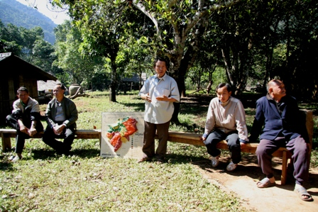
The old leadership board of Long Lan village, which consted of Mr. Pa Chong Zang (elder in-charge of Fatherland Front), Mr. Chong Vu Zang (village head) signed contract to lease out over 50 hectares of herbal forest to Mr. Kenh, a businessman for coffee plantation in 30 years since December, 2007. This is a bad error, which impact negatively traditional values and customary laws of Hmong in Long Lan. Villagers were unhappy, elders reacted strongly as internal disputes was more profound, that expose community forest at the threat.
Since the error against resources management of the old Long Lan village leaders, CHESH Lao gave advice and worked with Luang Prabang district, elders and villagers to vote new leaders to replace the old ones. With the new leadership coordination, strengths of customary laws and community rights for natural management since March 2008.
New leaders direct worked with Luang prabang authorities, Agricultural department of Luang prabang district to complete forest allocation procedure to decentralize land rights on 47 hectare to herbalist group. Village leaders supported herbalists to set up regulations for management, use and development of community herbal forest. The regulations then were approved by Luang Prabang district authorities. As the support and approval of district authority, community customary laws and the role of community in forest protection were clearly formally recognized. That creates foundation for the rights of customary laws, the rights of community for natural resource management and development, which were determined.
Base on the customary law and traditional community structure, village leaders solve conflict over resource use and management within and between Long Lan with neighbering villages successfully.
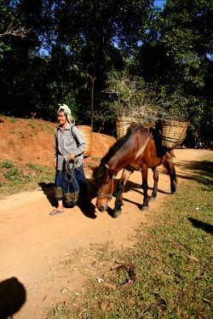
Long Lan leaders confidently supervises the village forest managing team to check forest often twice monthly, plus unusual cases. They transfer rights to group of traditional eco-vegetable to deal actively with setting up a organic fresh vegetable shop in Luang Prabang. That decentralization encouraged and maximized voluntary participation and creativeness of villagers. The eco-vegetable grower group actively deals with land procedures for setting up organic fresh vegetable shop at Luang Prabang City and encourages all villagers to collect non-timer forest products for the shop. The village forest protection team is able to deal with their task, so they discovered and set resolutions for two cases of forest violation by outsiders. Thanks to those group activities, community spirits and confidence of every involvers is accelerated. Therefore, decentralization help community strength to be maximized on the basis of customary laws and traditional social structure.
In accordance with supports of the new leadership, shop of organic freshe vegetables was set up in Luang prabang City while more households involve in vegetable cultivation (58 of the total 62 households). More importantly, there is no villagers’ violations against regulation so far. The villagers gain better trust in applying village regulations. That is the most outstanding of the results in Long Lan village.
Why did Long Lan villagers confidently decide to change village leaders although they had just voted two months ago? Mr. Pa Chong Zang, elder for Fatherland Front did not maintain reputation, but it was not so easy to dismiss him. However, existance of Hmong traditional institution and their forest is more essential, so they need to overcome the difficulty, which never happened so far. That illustrates the improved awareness, capacity and decision making of Long Lan villagers.

Herbal network of Long Lan, Xieng Da, Nam Kha determine their rights in community forest management and preservation of traditional herbal values
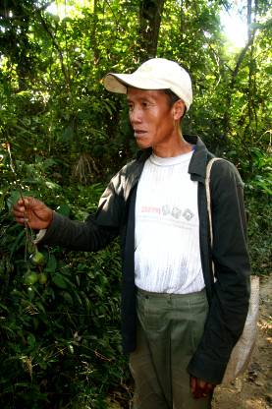
Herbal medicinal network of three villages of Long Lan, Xiang Da, Nam Kha was strengthened and worked effectively during this period. Together with villagers, elders and leaders of Long Lan village, herbal network and leaders of the mentioned three villages have voiced to Luang Prabang agro-forestry department, so that Long Lan herbal group gained 47 hectares of hebal forest; and Nam Bac agro-forestry department allocated 59 ha of herbal forest to Xiang Da village, 10 ha to Nam Kha village. Hebal groups encouraged herbalists to comp0se 65 herbal discriptions (of which Long Lan herbalists composed 35 discription and Nam Kha made 30) in their own language (Hmong and Kho Mu). By that way, traditional herbal discriptions of their ethnic groups are maintained and transferred to younger generations.
This is the first time, that Luang Prabang district authority allocates land for a herbal group to manage and use, and also the first time villagers integrate two different law systems for forest management and protection. Hmong and Kho Mu people in the two villages of Long Lan and Nam Kha mobilized community customary laws and state laws to deal with management and protection of their own resources. On the other hand, Lao Lum ethnic group of Xiang Da manges and preserves forest according to good customs, which attain the foundation of Buddha’s wish for natural care. Determination of the local herbalist rights of herbal forest has supported villagers to maintain their own values and moral behavior, which is accordance with their awareness of the meaningful values of the forest, which assure local life improved. Herbalists, elders of three mentioned villages understood that, community herbal forest preserve social values, community spirits, because it creates ideal environment for exchanging, training and community solidarity. Herbal forest does not only offer herbs for illness treatments, but also offers favourable condition for promoting traditional education for young generations, preservation and extension of local knowledge, traditional social structure as well. The forest contains values of belief, religion, which are protected through strict customary laws of each community.
Observing effective activities of herbal groups, Luang Prabang district Healthcare department recommended to cooperate with herbal groups to develop herbs in the forest. Villagers, especially herbalists of surrounding villages of Nam Kha suggested Nam Kha herbal group to cooperate to share hebal know-how and protect herbal forest.

VTHEN was set up, that illustrate the peoples’ needs for linkage, and improvement of their capacity and awareness, to create new environment for cooperation between different ethnic groups
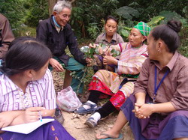
Study tour to Long Lan village and sharing between Vietnamese herbalists (Thai, Hmong, Kinh ethnic groups) and herbalists from Northen Laos (Lao Lum, Kho Mu, Hmong ethnic groups) does not only resulted in 350 herbal discriptions to be exchanged, but also created new dimension for linkages and cooperation. They combine to share knowledge of herbal utility and get more awareness of and act to preserve their traditional cultural values.
Thanks to exchanging, different ethnic groups from the two countries came up to an agreement of setting up Lao-Viet Traditional Cultural Herbal Network (LVTHEN). They voted a leading board, which consisted of one leader coordinator and five other assistants. Herbalists, who are members of the network discussed together to set up objectives, development stretegy for the network. This is the foundation for further linkage and extension of the network to the Mekong region.
Linkage of the network does not merely meet the members’ needs for exchanging herbal experiences, importantly it contributes to strategy of preservation and nurturing of biodiversity base on different ethnic groups’ knowledge through successive generations. The strategy targets at increase of both forest area, number of herbs as well as herbal discriptions and knowledge.
Methodology of Lao-Viet network of herbalists, which bases on herbal forest, herbs, herbal discription reflects harmonious relationship between three main factors: human, the nature and culture. The network is concerning about the way which could promote preservation, nurturing of belief, values, diversity of culture, biodiversity of different ethnic groups in Mekong region.

Preserve belief of natural spirits of Lao Lum ethnic group in Xiang Da village thruogh ‘‘Buot ton may’’ ceremony
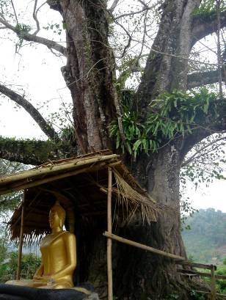
Lao Lum group in Xiang Da village wants to preserve and modify inherent traditional cultural values as well as Buddha or natural heritages through ‘Buot ton may’ ceremony. The ceremony for land allocation from Nam Bac district to village herbal group is combined to this context. Buddha, pagoda, old tree (Bo De), the dragon are symbols of sacred of Xiang Da villagers. ‘Buot ton may’ ceremony serves for transferring souls and vitality from Buddha to the trees. Its rites link people of actual life to Buddha and forest trees, which aim at strengthening belief and incline to the good. That is good opportunity for traditional education, in which the elders try to train youngers in honest, peace and respect to nature.
Dealing with outsiders’ threat of deforestion, Xiang Da villagers applied customary laws to attach Buddha’s yellow cloth to forest trees, to notice that trees are absorbed by Buddha’s soul. Whoever see those forest trees with Buddha’s cloth, surely they will not cut or disburb. That is the first creative application of Lao Lum group in Laos.
‘Buot ton may’ ceremony was held at large dimension, that is not only meaningful for cultural preservation, but also forest protection base on inclining to the good. The meanings apply to both Xiang Da villagers and outsiders. That is why Xiang Da villagers invited high-rank reputable monks from Luang Prabang, who inspire strongly people’s conception and behaviour.
Nam Bac authority agreed, supported Xiang Da villagers’ suggestion for holding ‘Buot ton may’ cermony, and then they sent representatives to join. Director of Luang Prabang provincial agro-forestry department and army representatives supported this Xiang Da ceremony, i.e. they support community customary laws values in nurturing the nature. In other words, Xiang Da people determine their customary laws as local authorities’ recognition. This is not only administrative meaning, but also meaningful in social, cultural aspects. Base on that, villagers gradualy gain more confidence in building their better life. Xiang Da villagers feel happy, confident because ‘Buot ton may’ ceremony had offefred them chance to strenghthen and practice goodness, caring for forest and land.

Building up sustainable agriculture practices
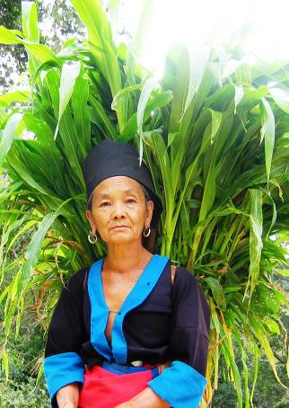
Many Long Lan families gave up shifting cultivation and started with a sustainable alternatives i.e. growing vegetable, teak plantations and raising buffaloes, cows, pigs, while women spend more time for weaving and traditional handicraft. CHESH Lao gave advice and accelerate that changes through villagers’ perception and their suitable reaction to the new context and challenges. CHESH Lao created various opportunities for villagers to join study tours, to share, exchange experiences with other ethnic groups of different localities within and outside Laos. Villagers’ awareness and capacity was imporoved gradually as CHESH Lao provided regular training, workshop on development issues. Villagers understood that, they should mobilize their own strengths, i.e. traditional work and products, so that to deal with market successfully. Base on their local knowledge and natural advantages, Long Lan villagers focused on growing organic fresh vegetable. They have calculated and see clearly that, organic vegetable is much more effective than old shifting cultivation. So far, 58 out of 61 households of Long Lan village grew and got income from organic vegetable. They intend to promote their own image and trademark of Long Lan organic vegetable in Luang Prabang. This also illustrates improvement of the villagers’ perception.
Similarly to Long Lan, at least 20% of households of Xiang Da and Nam Kha villages changed from shifting cultivation to wet rice transplanting and gardening. Some households decided to sell out shifting land area as they found that land was as not effective use as other jobs. Two good sustainable agriculture garden of Mr. Som Lit (Xiang Da village) and Mr. Thong Phay (Nam Kha village) gained good outcomes. Mr. Som Lit developed seeds of elephant grass and nitrogen fixing trees, which were collected from Vietnam after his sustainable agriculture training course in Ha Tinh and Quang Binh provinces, Vietnam. This is a convincing indicator for awareness improvement through organic agriculture network.
Ecological organic agriculture practices are recognized by villagers of three project villages of Long Lan, Xiang Da and Nam Kha, though this concept is neglected in Laos. Since better awareness, Hmong people understood values of their traditional organic vegetables, then they decided to develop them in order to preserve the traditions and contribute to improve households’ income.
Changing from shifting cultivation to organic vegetable, develop sustainable agriculture illustrates people’s active adaptation to the new conditions. Those are Laotian government’s aim at decreasing defforestation for cultivation and the market demand for safe quality products. Perceive and adapt to that, people of the three mentioned villages actively change for their better livelihood while maintaining their cultural values.
Networking of interest groups and CHESH Lao’s advice have served inputs for those changes. People got further confidence, independence while they improved their skills of analysis of difficulties, challenges, potentials.

Maintain and develop handicraft
Handicraft members of Xiang Da village produced products of natural dyeing. They are skillful at natural dyeing as they practice using forest and garden trees to dye 12 different natural colors. Dyeing quality is good, the handicraft products are not discolored after washing or exposure to the sun. There are three main types of products, which were produced last year: scraft: (200 pieces), table-cover (160 pieces), handkerchief (100 pieces), and 600 meters of cloth. Recently the group sold out to get an amount of 3 million kips, of whom Nang Nhung got highest of 500,000 kips, and Nang Van got the least of 200,000 kips). Nam Kha handicraft members finished 40 pockets made of forest tree fabric and natural dyeing. They sold out products to get an income of 1,250,000 kips. Moreover, those above handicraft products are introduced and interested by consumers in Vietnam and Thailand.
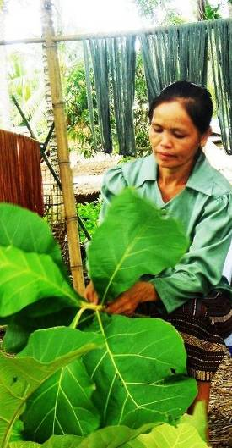
The network members actively self-arrange time to produce without any outside advice. Since the recovery of handicraft, Xiang Da women set up contacts with outside partners to get contracts for selling out their products. They combine traditional natural-dyeing products and products according to the contracts. Therefore, they obtain stable income of an average of 800 thousands to 1 million kips per person per month.
Recently, more than 30 Kho Mu households are being moved from other villages due to the resentment program to live in Xiang Da village recently. Kho Mu women asked those of Lao Lum to train them weaving, so that to get the work and get more income. Mrs. Xy and Mrs. Van become trainers for Kho Mu women. Nowadays Mrs. Ke can weave well to create handicraft for her family members’ utility.
Moreover, Xiang Da women can understand the design and create more new patterns for Luang Prabang market, to meet the customers’ demand in 2007. On the other hand, they do not neglect traditional cotton fabric and natural dyeing products. 8 women maintain a total area of 8,000 square meters for growing cotton and maintain natural dyeing for finishing Lao Lum tradtional cloth.

CHESH Lao office confidently coordinate and organize development activities
CHESH Lao office, which was establish at PAFO office in 2003, maximizes its functions of coordination to support field activities so far. The office has created favourable condition for sharing, exchanging between staffs and villagers of three project villages. The office becomes a central point for coordination, cooperation and linkage with such agencies as Lao Ministry of Agro-forestry, Luang Prabang Agro-Forestry department at provincial and district levels, Luang Prabang provincial Planning and Investment department, Vietnamese Consulate in Luang Prabang, Luang Prabang provincial authorities, authorities of districts of Luang Prabang and Nam Bac. The office also organizes, observes, monitors training activities for resource personnel internally and internationally.
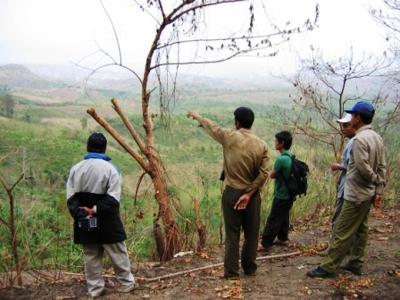
Four full-time staffs and two youths work at the office regularly. The staff are able to support community with plans and reports. They improved their awareness and approach to development activities. Mr. Phon Thip – chief officer can deal independently actively with monitoring report and support community actively. Ms. Ju Ly – an accountant confidently manages office financial work in a transparent and effective manner. Ms. Som Chit, an admin staff, a formal pupil trained by CHESH Lao, deals with office works well. Those CHESH Lao staffs can speak and communicate well in Vietnamese with other colleagues.
CHESH Lao office works effectively because of not only their enthusiastic work even at weekend, but also good linkage to relevant agencies, especially Agro-forestry departments of Luang Prabang and Nam Bac districts and other authorities of those districts.
CHESH Lao office’s coordination and linkage have accelerated Luang Prabang and Nam Bac Agro-forestry departments’ allocation of land to the herbal groups of the three project villages, and PAFO’s agreement to offer land to Long Lan villagers to set up a organic fresh vegetable shop in Luang Prabang City. The office links to get good legal framework for project villagers’ study tours and sharing internally and internationally. Thanks to good linkages, Luang Prabang authority decided to stop businessmen to hire land and promote cash crops (i.e. coffee and rubber plantations) in Long Lan village.
Importantly, villagers’ trust in local authorities are improved while district authorities adopted and recognized community regulation on natural resource management of Long Lan herbal group. The period of 2007 - 2008 observed changes of relevant agencies of Luang Prabang and Nam Bac districts while they willingly cooperate to prevent and solve forest violators. Agro-forestry department of Luang Prabang district have solved two forest violation cases in the second half of 2007.
CHESH Lao office supports to organize training at FFS, HEPA, Vietnam for five Laotian youths in the beginning of 2008, two of whom continue their study so far. They will become a core group who set up organic farming at their community to share with other villagers in the future. Mr. Ku Tho and Kham Phay, the two mentioned youths have applied learnt lessons to their own farm during their leave.
CHESH Lao office was highly appreciated by Luang Prabang provincial Agro-forestry department and PAFO that it is a model of effective sustainable actor.
Link and maximize participation and support from authorities from local to central level is the strategic approach of CHESH Lao. CHESH leaders worked and agreed with Laotian Ministry of Agro-forestry on the methodology and objectives of the programme. Therefore, the Ministry appointed Mr. Chan Tha Net to supervise and support CHESH Lao with legal framework and such strategy as land allocation, linkage interest groups from different areas for study tours and experience exchanging. Director of PAFO (Mr. Som Phong) is in-charge of CHESH Lao programme before Laotian government. So Mr. Som Phong is responsible for signature of certification and approval of the programme’s plans and financial expenditure. He works closely with CHESH Lao and willingly supports and gives advice. For instance, he decided and signed a decision to offer a plot of land within PAFO for Long Lan village’s organic fresh vegetable shop. Besides, PAFO offers CHESH Lao an working office inside PAFO and considers CHESH Lao office is a integral part of PAFO. CHESH Lao staff are invited to participate in regular meeting of PAFO. Mr. Phon Thip is assinged by PAFO to coordinate and link between CHESH Lao and PAFO.
Approach Analysis
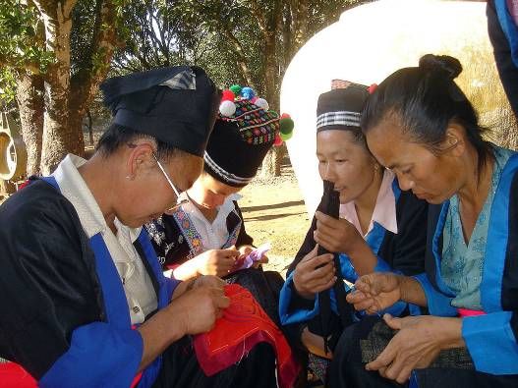
Luang Prabang district leaders assinged Mr. Bun On, director of district Agro-forestry department while Nam Bac district leaders appointed Mr. Un Huon, vice-director of Agro-forestry department to supervise and participate direct in CHESH Lao activities. Besides, Luang Prabang district authorities asked Mr. Cho Xy Zang, a Hmong man, director of Organizing department to support direct Long Lan village to carry out project activities.
CHESH Lao respects and willingly cooperates with state agencies, that is strategy for creating opportunities for the community’s thematic networks to share with each other. CHESH Lao cooperate well with Laotian Ministry of Agro-forestry, Luang Prabang provincial Agro-forestry department and professional departments of Luang Prabang and Nam Bac districts in 2007 – 2008 period. By coordination, those agencies and local people discussed and found suitable solutions for sustainable management of local natural resources.
Importantly, CHESH Lao supports to create some good models of sustainable management of forest, land and organic fresh vegetable production in Luang Prabang province. CHESH Lao creates democratic atmosphere for such thematic networks as herbal medicine, handicraft, organic fresh vegetable to maximize their strength through cooperation.
Strengthen and enhance capacity and linkage of thematic network (Customary laws, herbal medicine, handicraft, organic farming). Activities are initiated from community’s needs, which are discussed amongst the network and between the network and the community. Network members actively set up their plan, then they introduce and get advice, approval from elders and village management board before implementation. Herbal medicinal network of three villages of Long Lan, Xiang Da and Nam Kha feel free to set up their planning, and make inventory of herbal resources. Thematic networks actively deal with receiving guests, introduce and exchange with other network and outsiders.
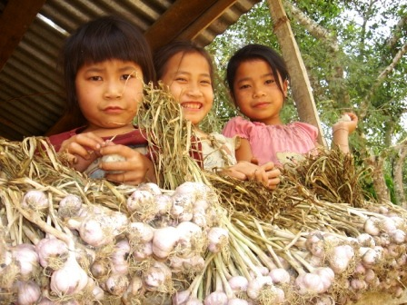
Special concern to community-based approach: base on traditional knowledge and customary laws, the role of elders and inherent internal strength of the community. Community regulations of forest, agricultural land management and protection have been set up in Long Lan since 2005. With the role and enthusiastic involvement of elder Xay Khu Zang, who is very respected by villagers, community becomes more active. Lao Lum people in Xiang Da base on their traditional handicraft and belief in Buddha, with the role of Mr. Som Lit, Mr. Chan Keo, who are pioneering go ahead. Kho Mu villagers in Nam Kha rely on responsibility of Mr. Thong Phay and knowledge of Mr. Bun Chin Lieng Pha Chanh.
Create good chances for authorities and professional staff of the two districts of Luang Prabang and Nam Bac to go to field to understand reality of difficulties, constraints, so that to find suitable advice and solution with the villagers. Mr. Cho Xy Zang, official in-charge of highland, also head of Zang clan has important voice in Hmong community in Luang Prabang. Thanks to influence of Mr. Cho Xy, elder Xay Khu agreed to come back to involve actively in community activities in Long Lan village. On the other hand, Mr. Som Mai and Mr. Bun On, director and vice director of district Agro-forestry department actively concern forest and agricultural land management. Therefore, disputes in forest and agricultural land between Long Lan and Nam Bo villages were initially solved while Mr. Phon Xay and Nam Bo villagers are absorbed to participate in the resolution process. Chairman of Nam Bac district is interested in project in Xiang Da and Nam Kha villages. Mr. Un Huon, vice director of district Agro-forestry department, who involve in, supervise and understand the project for a long time willingly support direct project activities. Those authorities support a lot to attain good organization of ‘Buot ton may’ ceremony in Xiang Da village.
Integrate state policies to traditional local knowledge and customary laws
Long Lan villagers based on their traditional knowledge and customary laws to set up community regulations on forest and agricultural land management since 2005. On that foundation, the herbal group also set up their regulations. Village leaders applied provisions of state Land law and Forestry law to allocate land to herbal group. Base on Buddhist idea, Xiang Da villagers creatively apply ‘‘Buot ton may’’ traditional ceremony to ordain trees as monks, so that to make protection of the forest more effective. Nam Bac authorities apply state laws to complete land and forest allocation to the herbal group. Those decisions do not conflict each other, they harmoniously integrated with the common aim at effective management, protection of forest.

Through training, discussion, sharing, focus on CHESH Lao staff’s capacity building and awareness raising in objectives, strategy, approach to organize and implement project activities for the period of 2006 - 2009. At the same time, those staff are offered opportunities to carry out activities at the field according to their discription of detail professional duties.
Approach to natural resource management of Hmong community of Long Lan village was divided into three phases:
Lessons Learnt
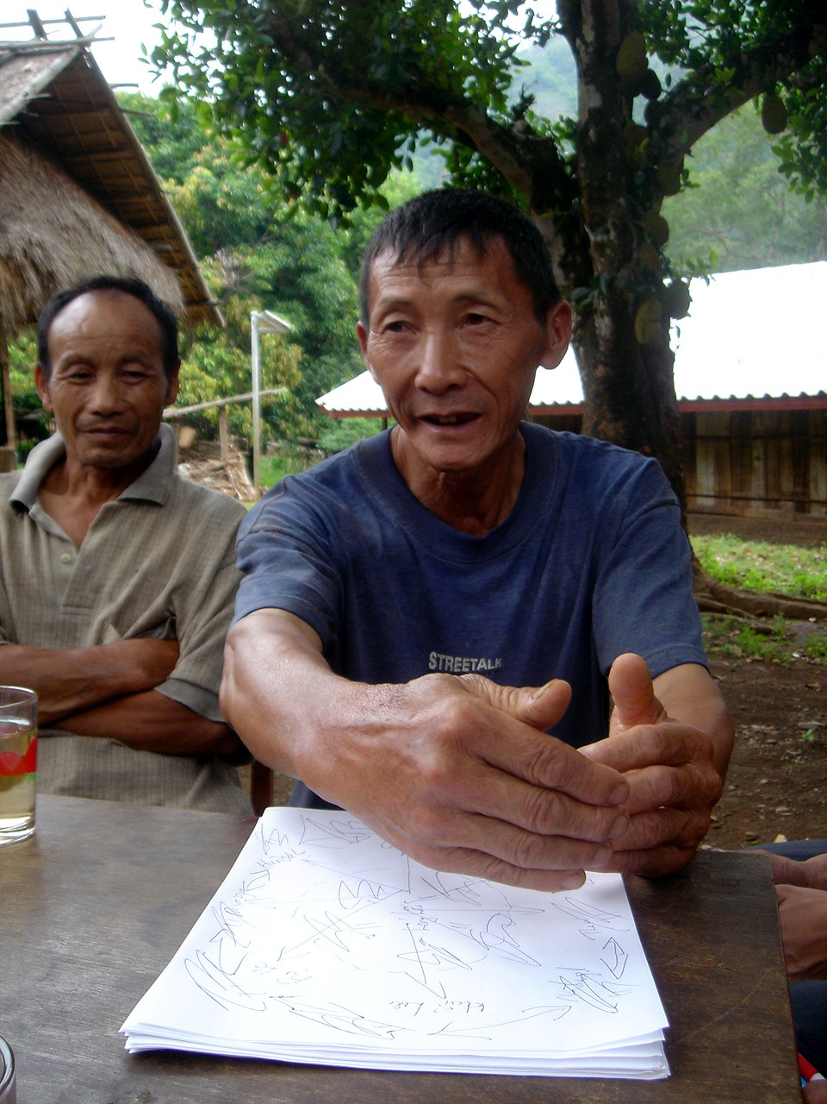
First phase: CHESH Lao focused on study of interaction between ecology and traditional power structure of the community. That was relationship between forest and land and 7 clans through Nao Long ceremony in the Long Lan village, spiritual relationship between human and the nature, local knowledge in planning of natural resources in a sustainable way. CHESH Lao drew out leant lessons that, in order to manage natural resources sustainably, it was necessary to study those relationship in the interaction with state formal administration.
Second phase: CHESH Lao focused on study on: a) Formal power structure, b) Traditional power structure, c) Ecology of Long Lan village in land allocation and community-based land planning. CHESH Lao drew out learnt lesson that, relationship between ecology and huam may be break down because of unsuitable state policies, especially those related to land bordering, land and forest classification. That caused a lot of conflicts of the interests and power in land management and land use. Therefore, integration between traditional customary laws and statutary laws would help to regulate human behaviour and action, so that to minimize conflicts and manage natural resources in sustainable way.
Third phase: CHESH Lao study interaction of human-ecology-politics-market through approach to planning of sustainable agriculture and organic vegetable. CHESH Lao gained learnt lesson that, land allocation, which had solved conflict of bordering would not be able to sustain against negative impacts of the market. Market would stimulate human demand for natural resources. If there was no suitable strategy and approach, balance of ecology would be broken because of human abuse since the market demand.

Grassroot democracy is set up and maintain, which base on respect to community traditional values and customary laws and the statutary laws. Long Lan and Xiang Da villages are good example for the integration between traditional system represented by elders and formal administration represented by voted village leaders. Mr. Xay Khu Zang is spiritual leader elder of Hmong in Long Lan village, but he is not in the list of elders of Fartherland Front, which is suggested by district authorities. Then Mr. Xay Khu Zang was accepted as advisor for elders’ council and village leaders by the district authority. That illustrates that, local authorities understand and respect traditional spiritual leader. Besides district authorities approved two community regulations of Long Lan: one for management of herbal forest base on customary laws and the other for relationship and cooperation with outsiders. This approval create democratic environment for community. Nam Bac district authorities supported ‘Buot ton may’ ceremony which served to transfer Buddhist soul to trees, that was the recognition of Lao Lum traditional practices and democratic environment.
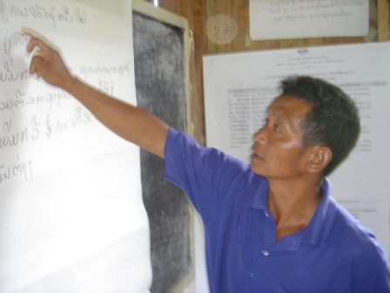
Self-responsibility, self-determination are built upon decentralization of (a) land, forest; (b) community management; (c) people’s participation and contribution of initiatives.
Decentralization only make sense whenever indigenous structure, customary laws, moral values are recognized. People’s initiatives only appear if there is good condition for encouraging people’s voices in democractic environment. Since the approval of Long Lan community regulations and land allocation by Luang Prabang district authorities, villagers actively check and solve cases of forest violations. They organize themselves to visit and check forest twice every month without any support from district authorities. Moreover, villagers sent requirements to district authorities for their cooperation to check and solve violations.

According to CHESH Lao, programmatic approach means: (a) extent values and participations of different stakeholders, who share interests, concerns for the sake of target beneficiaries, (b) involvers are not only NGOs, but also business sector, or government agencies, (c) create opportunities and ground for beneficiaries to control and implement their own development, and (d) therefore, require donors and NGOs a long-term, holistic vision and strategic planning.
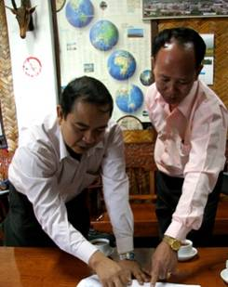
The Ministry of Agro-Forestry of Laos (MAF) – Partner of Center for Human Ecology Studies of Highlands (CHESH) who takes reponsibility to be umbrella for the cooperation and development between MAF and CHESH in Laos.
Project for Rural Development of Focus Area (PRDFA), and Agro-Forestry Extension Department, the Ministry of Agro-Forestry of Laos – who takes responsibility to carry out the cooperation and development program between MAF and CHESH in Luang Prabang province, mostly from 2000-2003.
Partners of CHESH Lao Program
Land Allocation Department of the Ministry of Agro-Forestry of Laos - involved in land and forest allocation, and land use planning in Long Lan village, LuangPrabang province.
Luang Prabang Provincial Agriculture and Forestry Offices (PAFO) - who take responsiblility to implement the cooepration and development between MAF and CHESH in three pilot villages such as Long Lan (Hmong people), Xieng Da (Lao Lum people) and Nam Kha (Kho Mu people), in Luang Prabang province.
Luang Prabang and Nam Bac District Agriculture and Forestry Office (DAFO) – who take responsibilities to directly advise for local peoples in terms of community development, techniques advices, etc.
The National Dong Dok and Syhanuvong Universities – with CHESH Lao Program to co-conduct several micro scale action researches at the pilot projects in the three villages (Long Lan, Xieng Da and Nam Kha).
The Luang Prabang provincial of traditional health care office - involves to advise for herbal medicine networks at the three village.
The Luang Prabang provincial commercial chamber office - involves to advise for Long Lan Hmong people to run a shop in ecological fresh vegetables
The Local Luang Prabang provincial media (news, TV and radio) - involve to desiminate information lrelated to the pilot projects in the three villages (Long Lan, Xieng Da and Nam Kha).

After 8 years of advice and support by CHESH Lao, community of three villages of Long Lan, Xiang Da, Nam Kha have achieved mid-term objectives: Villagers actively confidently and creatively self-organize community activities and their own household economic affair. Long Lan became a pilot model for human-ecology village while Xiang Da villagers recovered traditional belief and handicraft. Nam Kha village eradicated hunger and Luang Prabang provincial authorities recognize the village as Xam xa at (village of three sanitations).
Challenge Analysis
However, the three mentioned villages and other villages as well face challenges, which will be even harder in the future:
No changes in government policy of resettlement and uniting different villages into one. Villages, which does not contain enough 35 households will be able to unite to other villages. That will not only cause difficulties for managers, leaders of the village, but also impact specific cultural values of each ethnic group. For instance, Phen village in Nam Bac district, Luang Prabang province used to be a village of 30 households of Kho Mu group, which is 5 km east of Xiang Da village, then they had to merge with Xiang Da village according to government decision in 2006. All villagers gave up their inherent garden, community forest to resettle at Xiang Da village area, so Phen village dissappeared. Xiang Da increased the number of households from 123 in 2006 to 160 households recently. Though Phen villagers made houses in Xiang Da village, they still come back to practice on their old inherent field, so their life become more difficult. More seriously, their cultural values are exposed to undermine.
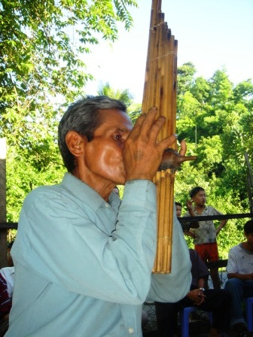
Lao government give favour to internal and oversees companies to invest in mining, hydro plants, industrial zones and golf. Therefore, people lose their land while natural resources are expoilted to exhaustion, that danger people’s livelihood and their culture.
Long Lan vilalgers deal with a big question that, how to protect their forest well if other surrounding villages face shortage of land and forest disappearance.
Fair-trade for Long Lan organic fresh vegetable merely expand to a scale of a pilot model. The villagers are challenging with increasing free market in Laos whenever they try to balance culture, community spirits, indigenous knowledge, economic and environmental aspects.
Maintenance, expansion, linkage of Hmong customary laws to those of other ethnic groups of neighboring villages, districts for larger network of natural resource management are essential strategy. However, that require support of experienced expert with available time, energy and finance.

Case1: New leadership board of Long Lan village and their dynamic, determined actions
Case Studies
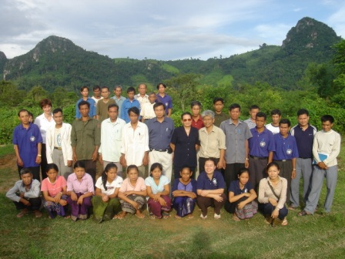
Right after the voting dated 5th March, 2008, Long Lan new leadership board dealt with a lot of challenges. One of which is the forest damage and land encroachment by outsiders. Threat of losing land, forest, and also cultural values become reality in the short time. To insight that, new leadership tried their best with effective detailed solution and relevant actions. The first solution referred to strengthening of internal solidarity and stimulate each members’ responsibility according to Hmong cultural values. Mr. Za Zi Zang, new elder in-charge of Fatherland Front said:
"We have our customary laws for generations. We contribute much labour for land allocation and setting up our regulations. If some households sell out allocated land, then outsiders enter to destroy our forest, our village will expose to danger.
The leadership board then applied the following solution: to fine, so that to deter others. Mr. Xay Khu said: "district authorities do not punish anything, so we will apply statutary and our regulations to fine against violators. That will make them afraid and won’t dare to repeat."
The new leadership proactively treated those cases at the end of March 2008: applied community regulations to fine violators from Khoc Va village, who collect herbs and trees for fiber without village’s consent. Those violators entered to forest nearby Ka Sia-Phu Sung, which is not close to the villages nearby herbal forest. Aware that outsiders exploit forest, Long Lan leaders organized village security team headed by Mr. Kong Chu Ly to check and catch 5 violators with 30 sacks of herbs and fiber to the village. Then the village head read statutary forest laws and community regulations and said: Apply statutory laws, we would fine 50,000 kips for the first violation, according to village regulations, the fine should be 200,000 kips. Because we are neighbors and friends, so we apply a fine of 100,000 kips and let you take those herbs and fibre back home. Please do not repeat this. If you want to collect herbs for illness treatment, you need to ask us for consent. Those violators had to follow Long Lan leaders’ decision. Then vvillage leaders asked Mr. Za Zi to present the case to Luang Prabang authorities and CHESH Lao.
This is the first breakthrough action of Long Lan leadership board, without any antecedent. In the past, village leaders simply report to and wait for district authority’s resolution if they discover forest or land violation. However, district authorities did not go to the village, or their resolution was too late, then this is not an effective way. Recently things changed because of proactive resolution by village leaders instead.
Apply customary laws to fine some Bo He villagers, who infringed a tomb of Long Lan village. A household of Bo He village cleared land for cultivation field, but they encroached Long Lan land and infringed the tomb of Ms. Mo Mua past husband. That is unacceptable according to Long Lan customs, so the villagers reported that case to Xay Khu and other leaders of the village.
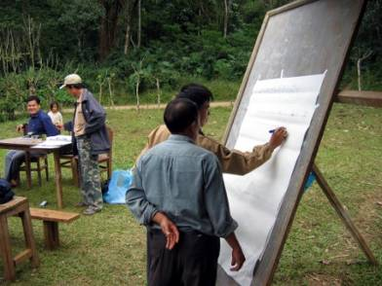
Mr. Xay Khu said: Fine is deserved ill of forest damage alone, moreover they infringe other’s tomb. If we merely apply statutary laws, they will not be afraid, so we need to apply customary laws. That family have to pay a pig of at least 100 kilogram, or a cow for the endamaged family to worship and care for their ancestor spirits, so that the village will be free of guilty. We should invite a woship man to carry out.
This kind of punishment exist in Hmong customary laws inherently, but they have not practiced it for a very long time. Such application to outsiders even extremely rare. However, Long Lan elders determined to apply this case so that to maintain their customary laws, simultaneously prevent ousiders from continuous forest destroy. That is profound responsible decision of the village leaders. That make outsiders be more careful if they want to access to Long Lan forest.
Leadership board of Long Lan village decided to allocate nearby low sloping forest to herbalist group for protection, utility and management. Then technical team and hebalist group measure and map the area of 47 hectare of land. They understand clearly that, forest will be well protected if herbalist group take their rights and obligations, that is additional support for the leadership board to complete their duty effectively.
Due to those successive alternatives, Long Lan leadership board have possitively breakthrough for their forest and land management improvement, that used to be impossible by the predecessors. Is that community concern of their forest, customary laws to be lost, so thay determine to act so strongly? They would not accept their forest to be destroyed and their ancestors’ spirits become unrest. The clue may be that, forest does not only mean foundation for livelihood, but also Hmong’s source of life.
Such strong actions may come from improvement of awareness of elder-advisor, elder-in-charge of Fatherland Front, village head and vice head. Stronger reasons may depend on perception of threat to their forest, and no other way, they have to react to preserve their forest and their customary laws, traditional structure as well.
Mr. Xin Kham, a technical staff said: "Long Lan leaders are now very strong, because they have organizational skill and respect. In the past I have to initiate for organizing village meeting, they accepted all things I said. Nowadays village leaders take the role of leadership. It was difficult to mobilize villagers previously. Recently I do not to lead anything except writing and calculating, because defining border or measuring is proactive taken by the villagers. In the past no one among villagers dare to write on the board and present in front of populace; nowadays they do it confidently".
Since those first strong leaders’ and Long Lan villagers’ actions, foundation for natural resource protection and customary laws, social structure may be maintained and enhanced in the future.

Case 2: Clear-head discovery of development workers
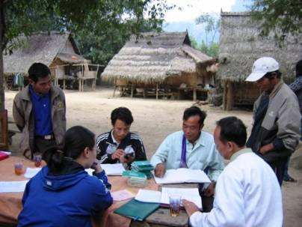
There was no activity for supporting ‘Buot ton may’ ceremony for Lao Lum at Xiang Da village in CHESH Lao six last month plan. However, after learning needs and constraints of Xiang Da villagers, CHESH Lao leader (Mr. Dam Trong Tuan) discovered that Lao Lum people have a special ceremony of ‘Buot ton may’, which ordain for monks and pagoda and forest trees. Whenever a tree is ordained (Buot), no one dare to damage. The question was that, is that a good solution to solve problem of damage of Xiang Da forest continuously? After CHESH Lao staff’s sharing with elders and village leaders, elders agreed to organize ‘Buot ton may’ ceremony, so that to strengthen community cultural values and save village forest.
Moreover, Xiang Da villagers suggested to combine ‘Buot ton may’ ceremony with ceremony of transferring land title of herbal forest to villagers and herbalists. That is good combination between traditional customary laws and statutary laws, which is created by Xiang Da villagers. Due to participation of several outsiders and authorities to ‘Buot ton may’ ceremony, it create good opportunity for villagers to announce everyone that, forest is spiritually preserve by monks and pagoda, and practically protected and managed by herbalist group.
That is the first time ‘Buot ton may’ and Xut ton may were organized at forest in Luang prabang, and the first time big trees were tied with yellow cloth from monks of Luang Prabang. Then Xiang Da villagers get more confidence to keep their forest proactively.
This is an example for keen reaction and linkage between research and development by development workers, which are suitable to community’s needs and strategic action of CHESH, that is nurturing the nature.
- The six monthly reports of CHESH Lao Program (July-December, 2007 & January to June 2008).
Reference
- The yearly narrative reports of CHESH Lao Program (2000-2003, 2003-2005, 2005-2007).
- Minutes of different simenar, workshops, meeting hold by CHESH Lao Program at different levels (e.g. villages, provincial, national and international).
- Related articles posted in www.dolame.speri.org
- The yearly report (Jul, 07-Jun, 08) of the Traditional Handicraft Textile Network, Department of Community Development (DECODE), SPERI.
- The yearly report (Jul, 07-Jun, 08) of the Traditional Herbal Medicine Network, Department of Community Development (DECODE), SPERI.

New leadership board of Long Lan village consists of Mr. Blia Tua Zang (village head), Mr. Za Zi Zang (elder in-charge of Fartherland Front), Mr. Xay Khu Zang (advisor), Mr. Chong Ku Ly (vice village head).
1. Mr. Bua Zia tho – vice head of elders’ council (old elder in-charge of Fatherland Front, who is re-voted) 2. Mr. Kong Minh Zang (new member) 3. Mr. Pa Xo Ly (new member) 4. Mr. Chia Po Ly (new member) 5. Mr. Xenh Hu Ly (new member) 6. Mr. Xay Tua Zang (new member) 7. Mr. Cho Va Ly (new member) 8. Mr. Xua Cho Ly (new member) 9. Mrs: Nang Mo (new member)
New leadership of Long Lan village composes of Mr. Blia Tua Zang (village head), Mr. Za Zi Zang (elder for Fatherland Front), and Mr. Xay Khu Zang (adviser), Mr. Chong Ku Ly (vice village head).
For instance, they arranged conflict resolution for Tin Pha and Bo He area. As the head of Zang clan, Mr. Cho Xy Zang gave advice to solve conflicts in the village internally. Long Lan villagers agreed to contribute 173 hectares of Tin Pha land to Nam Bo village, so that they gain friendship. Mr. Xay Khu said: Tin Pha area is the common land of Hmong, Our villagers and those of Nam Bo are close relatives. If they are suffering from land shortage, how can’t we avoid contribute to help them? Long Lan villagers also applied peaceful solutions to 11 surrounding villages. Elders and professional staff use village regulations to interprete direct at the field to surrounding villagers and violators. That helped surrounding villagers get more understanding of Long Lan, and make their tie more close.
When Bo He villagers clear field, they took some land of Long Lan to dispose the tomb of Mrs. Mo Mua’s past husband. That is unacceptable by Long Lan villagers, so they reported this case to Mr. Xay Khu and other village leaders. Mr. Xay Khu said: One should be fined merely for forest distroy alone, other thing is damaging others’ tomb. If we apply state laws for this case, they are less afraid, so we need to apply our customs. Then that family have to pay at least a pig of 100kg,or a cow to the loser to worship spirits, so that spirits would protect that family and the whole community. We need to ask spiritual leader to help this worshipping for a whole day. Hmong used to practice this fine, but that has not been applied for a long time, especially that apply to outsiders. However, elders and villagers tried their best to apply, so that to keep their customary laws and prevent outsiders from entering to damage Long Lan forest. That is thoughtful view and responsibility of the leaders. That is also a good lesson learnt of respecting community rights for outsiders.
Long Lan vegetable development group sent a petition dated 10th March, 2008 to CHESH Lao anf PAFO for a plot of land for vegetable introduction shop. Base on that petition, CHESH Lao staff (Mr. Le Van Ka and Mr. Phonethip) worked with Mr. Som Phong, director of PAFO.Mr. Som Phong said: This is a good suggestion, which is suitable to PAFO strategy. Long Lan in particular and Luang Prabang has strength of organic vegetable and tourism, so we should encourage them. PAFO appreciate, support and is ready to offer a plot of land within PAFO area to set up the shop. However, the shop should be built temporaly.Since the agreement of PAFO, CHESH Lao sent a formal letter dated 23rd April 2008 to PAFO, which referred the land allocation for setting up Long Lan shop.
See more detailed in the yearly report (Jul, 07-Jun, 08) of the Traditional Herbal Medicine, Department of Community Development (DECODE)-SPERI.
Hmong of Long Lan village and Xieng Khoang province, Lao Lum from Bo Keo, Xiang Da villages, Kho Mu from Nam Kha, Thai from Hanh Dich commune Que Phong district, Hmong from Si Ma Cai district, Kinh from Ha Tinh province - Vietnam (30 herbalists from Vietnam) gathered for exchanging in Luangprabang during 12th to 22nd December, 2007.
? Coordination board consists of Mr. Lam Bay, Hmong group from Xieng Khoang, Laos, leader of the board; Mr. Blia Tua Zang, Hmong group from Long Lan village; Mr. Thit Phai, Lao Lum group from Bo Keo province, Laos; Mr. Sung Seo Nha, Hmong group from Lao Cai province, Vietnam, Mr. Luong Kim Dung, Thai group from Nghe An province, Vietnam.
Objective of Lao-Viet Traditional Herbal Network: (1) Preserve and develop herbal resources through establishment of community cultural herbal forest and family herbal garden; (2) Preserve and develop traditional herbal work through enhancement of exchanging, sharing, training of herbal knowledge for members and and people of various ages; (3) Preserve cultural values through herbal knowledge and practices, customary laws in herbal resource management and protection and norms, values relating to herbal work; (4) Spread out herbal knowledge and practices socially for everybody, who is interested in.
‘Buot ton may’ is a ceremony for transferring souls and vitality from Buddha to trees in pagoda, it means ceremony for adoption of tree as a monk.. This is an essential ceremony of Lao Lum ethnic people, who follow and belief in Buddism, Bo De old tree, Dragon, Nang (Lady) Tho La Ni. Those are Lao Lum people’s vitality of spiritual and material life.
Xiang Da villagers organized ‘Buot ton may’ ceremony for community herbal forest, simultaneously a ceremony of receiving land certificate by the village herbal group. Two hundred people, including representatives from provincial, district levels, army, surrounding villagers. Especially four monks from Luang Prabang province, six from Luang Prabang district, two from Nam Bac pagoda, two from Na Xao pagoda and all monks from Xiang Da pagoda. At the ceremony, all big trees in the forest were attached with Buddha’s yellow cloths.
Lao Lum people belief that, Buddha represents for the good to chase out bad spirits, bad actions. Wherever Buddha exist, bad spirits cannot exist. Buddha and monks may made things free from bad spirits and sins. Whenever putting buddha’s yellow cloth on trees or a forest, those will be protected by Buddha, then bad spirits and bad behavior will be chase out and they will not dare to violate. On the other hand, human will gain more willingness and the good towards those protected trees and forest. So far pagodas across Laos have been practicing ‘Buot ton may’ ceremony for Bo de old tree and other trees of the pagoda. That is vital rites for building up a certain pagoda and planting of supporting trees. Besides, after ‘Buot ton may’ ceremony, monks would take the rest yellow cloth to put on forest trees.
Mr. Som Phong, PAFO director said: This is a very meaningful community activity contributing to forest management and protection. Other villages should learn to follow.
Mr. Chan Keo said: This activity is not very good for Xiang Da villagers, but also for outsiders, especially army solders. Surely they will not enter to cut down forest trees.
Mr. Chong Zia reckoned that: one can only get 2 tons of rice, 5 tons of maize from shifting cultivation, that is enough for family food, but they have to spent too much labour, as they have to spend a half day merely for walking alone. Additionally, they suffer from bad weather, animals and soil erosion. Planting organic vegetable require time for travelling. However, they do not spent much time for clearing forest or taking care for the vegetable, then they may harvest to get income of tens of million kip per year, then they may buy enough food and have some spare money for other works.
Since perception improvement, Mr. Som Lit set up a model garden of 28 hectares. He produced 17,000 seeds of aloe wood, together with other cultivation yield of 10 tons of rice, 35 tons of maize, 5 tons of garlic. Withi Mr. Som Lit’s advice, three other households of Phon Ngam village (nearby Xiang Da) learn to follow him. He offer seeds of elephant grass and nitrogen fixing trees to others to develop. Mr. Thong Phay, a Kho Mu man in Nam Kha village built up a model gardening of garden-fish pond-animal raising for the first time in Nam Kha village. From a poor condition, his family could buy a tivi set and motorbike at the end of 2007.
See more detailed in the yearly report (Jul, 07-Jun, 08) of the Traditional Handicraft Textile, Department of Community Development (DECODE)-SPERI.
Nam Kha women finished 7 Kho Mu pockets, Xiang Da women weaved 12 scrafs for the first round. Long Lan women finished 8 Hmong pockets, 2 sets of blanket covers, Xiang Da women weaved 8 scrafs, Nam Kha women finished 5 Kho Mu pockets for second round.
Recently there are three outside investors to Xiang Da: (1) Nang May invested 20 looms; (2) Nang Van Xi invested 15 looms; (3) Nang Deng invested 10 looms. The investors offer little industrial fabric and require cloth of 60 x 220 cm. They pay 8,000 kips for weaving a cloth. A good weaver may finish 4 cloth per day. A piece of product is sold at a cost of 50,000 kips.Evarage income is counted at 800,000 kips per person per month. Mrs Bua Van said: It is difficult to weave such small industrial fabric, because we hardly see it. We do not want to weave it and want to weave natural dyeing fabric. If there is available market for natural dyeing products, we will turn back to that.
Full-time staff: Phon Thip, Ju Ly, Som Chit, Duon. Youth: Vong Dao, Phu Thon.
Vong Dao, Phu Thon from Xiang Da village, Ku Tho from Long Lan village, Kham Phay from Nam Kha village, Si Von from Na xao village.
Article 46 of Lao Forestry Law provides that, 1st of June every year is the date for tree plantation for the whole population. On the other hand, Xiang Da villagers decide to organize Buot on August 15th yearly, then they use monks’ yellow clothes to tie to forest trees, so that to prevent from everyone’s cutting the trees. Article 28 of Forestry Law wrote: A household is entitled to collect a maximum of 5 cubic meters of wood for their household use. On the other hand, Long Lan community regulations provide that: A household, which settle in the village for at least 10 years can collect wood only in production using forest for their house building, but do not exceed 5 cubic meters of wood.
Mr. Xay Khu is advisor; Mr. Za Zi is elder in-charge of Fatherland Front; Mr. Blia Tua is head of the village; Mr. Kong Chu Ly is vice head of the village.

