Social Policy Ecology Research Institute (SPERI)
Yearly Narrative Report
July, 2007-June, 2008
Department of Development Studies - DES
1/7/2009

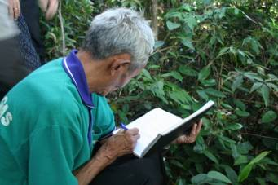
This report is done in the context in which MECO-ECOTRA & SPERI organization are in the middle term of reforming. More professional, more self-management, more strategic approach and more cooperation and linking are focal themes of DES in the reforming. DES’s findings in this report could be critical points for both DECODE and MECO-ECOTRA’s reference

Acronyms
AIPP: Asian Indigenous People Pacts
ANU: Australian National University
CRES: Centre for Natural Resources and Environment Studies - Hanoi National University
DAD: Department of Administration
DECODE: Department of Community Development
DEF: Department of Finance and Accounting
DELOBBY: Department of Lobby
DEFO: Department of Foreign Cooperation
DES: Department of Development Studies
CHFs: Community Herbal Forests
ECODE: Environmental Policy and Community Development
FAMIRE: Faculty of Culture, Minority and Religion, Ho Chi Minh Politics Academy
GNH: Gross National Happiness
MECO-ECOTRA: Mekong Minority Community Networking for Ecological Trading
FFS: Farmer Field School
ISEA: Institute of Social Entrepreneurship in Asia
HEPA: Human Ecology Preservation Area
LVTHEN: Lao-Viet Traditional Cultural Herbal Network
PRI: Permaculture Research Institute - Australia
SPERI: Social Policy Ecology Research Institute
RCSD: Regional C entre for Social Studies and Development - Chieng Mai Uni.
RNIP: Regional Network for Indigenous People

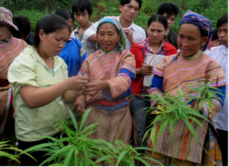
The Social Policy Ecology Research Institute (SPERI)’s efforts in the reform have been prioritizing. Therefore, Departments of SPERI, especially the Development Studies (DES) are required professional to meet new emerging needs of The Mekong Community Networking for Ecological Trading (MECO-ECOTRA).
Foreword
In the long-term, DES has been conducting the strategic research themes which would cover the emerging issues of indigenous minorities in Mekong region. The prioritized research themes include indigenous knowledge in ecological farming and cultural-biodiversity, customary law and local knowledge in watershed forest management, gender in land decentralization and household economic development, land and forest decentralization for conflict transformation, cultural identity of minorities, social capital and development via networks of interest groups at all levels.
In the year 2007-2008, in one hand DES aimed to achieve a department that is more (a) independent, (b) self-management, (c) professional, and (d) strategic in its approaches and conducting development studies in the longest run (expected in 3 years time). In other hand, DES has promoted more cooperation with academic and research institutes / Unis. to conduct research pilots and case studies at all levels.
In this yearly narrative report, DES addresses four important sessions towards the longer goals of SPERI as well as MECO-ECOTRA. These are:
- What and how has DES attempted in making changes in the process of organizational reform?
- What has DES achieved and not achieved after one year implementation?
- What are key findings or new appearances from the case studies implementation of DES?
- What would be strategic research themes for the policy research, theoretical research and action research for the next coming years?

Re-stating Objectives and Strategies for Reforming
DES in the Reforming

Research Topics

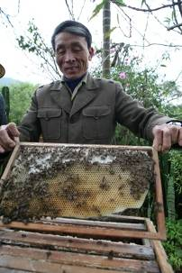
Research topics are being co-conducted by The Department of Development Studies (DES), the thematic networks of MECO-ECOTRA (e.g. customary law in watershed management, ecological farming, traditional herbal medicine, traditional handicraft and human-ecology village) and Farmer Field Schools (FFSs). Besides, DES has cooperated with some Vietnamese and oversee Unis. and Research Institutes to exchange and update knowledge and practices. By such cooperation, DES has focused on pilots to cover all levels of the studies such as action research, theoretical research and policy research.

At macro-level such as policy focus, policy lobby and policy analysis. Topics as followings are ongoing conducted by DESs.
- Clan rights of to land (forestland) of Hmong people - e.g. the case in Can Ho commune, Simacai district, Lao Cai province, northern Vietnam (Targeting January 2008);
- Transforming traditional civil society of Black Thai people - e.g. the case in Hanh Dich commune, Que Phong district, Nghe An province, Vietnam. (Targeting March 2008);
- Conflict transformation in natural resources management via community based-forest and forestland management and usage - e.g. the case in Long Lan village, Luang Prabang district, Luang Prabang province, Laos (Targeting June 2008).

At medium and micro levels (Applied studies)
- Sustainable organic farming practices at household and community pilots;
- Micro enterprises on green and ecological products at the local market: i) for herbal medicines, ii) for traditional handicraft produces, and (iii) for ecological farming productions;
- Preservation of local knowledge on farming practices and saving resources (effective uses of water, land rehabilitation, recycle of wastes); and
- Case studies on applied human ecology practices e.g. traditional land use planning.

Strategies for Reforming DES
Capacity Enhancement: DES has focused on two levels of capacity building for SPERI staffs and thematic networks of MECO-ECOTRA. For the SPERI’s staff, DES offers academic opportunities such as workshops, seminars on knowledge and skills of theoretical and policy researches. By this way, SPERI’s staff moreover updates information and theories related to development studies (e.g. civil society, social entrepreneurship, community forest, conflict transformation, human geography, etc). For MECO-ECOTRA, DES mostly enhances skills of farmers via co-conduction of action researches on different topics such as customary law in forest management, ecological farming, traditional handicraft, and traditional land use practices. Importantly, DES has looked for minority youths who are studying or already graduated from the Farmer Field Schools to train them to be action researchers. In the same time, they carry out action researches mostly in landscape design, recycle of wastes, and ecological farming system.
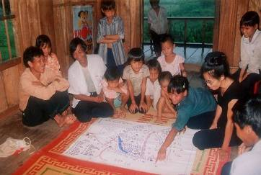
Decentralization and Quality Control: DES promotes self-management of each section and individuals (time, frame, finance, research studies’ outcomes), but quality control over outcomes (i.e. working hours in relation to work-outcomes); improve step-by-step levels of efficiency of each member; and encourage innovative and independent approach to carry out research studies/practices; whilst inquire members to achieve better level of quality control and ethics of information.
Information Management: DES has tried to set up a systematic and consistent system for instance research infor gathering, digital infor (photo, and other digitized forms, web development for site SPERI as well as its branches e.g. www.dolame.speri.org, www.vffs.speri.org, www.mekongdmp.net). Publishing achievements of SPERI and researches’ findings in the year 2007-2008 is prioritized as a strategy to raise public awareness and get public opinions for policy feedback.
Information and Knowledge Update: DES in cooperation with key research and development organizations to update and translate relatives documents for sharing with other SPERI’s Departments, particularly Farmer Field Schools (FFSs) and thematic networks of MECO-ECOTRA. For example, documents on indigenous people rights of AIPP, human geography and human ecology theories of Australian National University (ANU) and research methodologies of Center for Research and Development (RCSD)-Chieng Mai University.
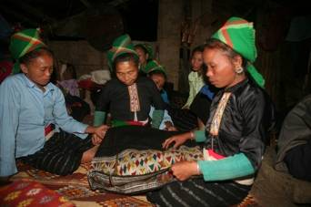
Promotion of Co-research with Research Organizations: For the year 2007-2008, DES in cooperation with FFSs’s partners such as Permaculture Research Institute (PRI) and YARD - Australia and the ecological farming network of MECO-ECOTRA has conducted several action/quantitative researches. Topics are mainly in solutions for soil improvement, landscape design, water management, etc.

Scaling up Researches’ Findings: Outcomes of DES as findings are being shared with academic and research organizations such as ANU, RSCD-Chieng Mai University, Ho Chi Minh Academy of Thought, etc. Moreover, DES’s strategy to publicize the findings to get larger audiences by cooperation with national magazines like The Literature Magazine, Saigon Economic Times, Policy Magazine of the National Assembly.
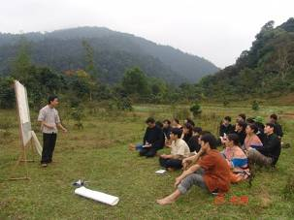
Reaffirming the Importance of Research Focuses
Yearly Review in Performance of Tasks

Issues at the Macro-Level
Three most crucial research topics encountered globally and locally and that, have required much involvement of indigenous communities, especially youths in the critical ecological highland areas are:
- Community rights to land and forestland;
- Emerging civil society at the community level; and
- Conflicts transformation in natural resources management.

DES with its function of looking critically at present and predicted development studies, sees that these three themes remain key research focuses; and research study sites remain key priority areas in 3-5 years time.

In the reforming SPERI and that of DES, it is important to build up chronological, logical, and systematic records of data and gather information of all forms and types. In other hand, those information are shared for public information and public debates via publications in some National Magazines like Literature Magazine, Saigon Economic Times, and SPERI’s webs.

DES sees this 3-5 years’ preparation (i.e. July 2007-July 2010) would be at fine time-scales to search for sound evident proofs cases so that assist in lobby purposes to promote Genuine Democracy at the Grassroots Level:
- Community Rights to Land,
- Civil Society Initiatives,
- Transforming Conflicts in a Non-Violent based Approach.

Table 1 - What have/have not done and achievable targets for each case.

Case studies | What have done? | What have not done? | Achievable target?
Case 1 - community rights to land (forest land) e.g. the case in Can Ho commune, Simacai district, Lao Cai province, northern Vietnam  (updated in July 2008) | - 60% of field data gathering (at primary level); data of all types (notes, recording, photos, videos, a series of reports);  - Distinction level of uses of field methodology (key informants e.g. individual local healers/villagers and FDGs);  - Accessible to formal maps, legal documents that give preferences to pro-community rights, literature review of pro-community rights;  - Two supportive analytical frameworks from 2 distinctive scholars (1) professional geographer (from ANU), and (2) well-known political scientist (from RCSD). | - Clustering datasets, classifying, and putting into the analytical framework;  - Data/information analysis and research reports  - Publication | December 2008 to March 2009 (finalizing the field data collecting and editing for publication
Case 2 - transforming civil society e.g. the case in Hanh Dich commune, Que Phong district, Nghe An province, central Vietnam.  (Updated in July 2008) | - A framework on understanding civil society ;  - Team work for the field research conduction  - Data and information analysis and research reports.  - A workshop among SPERI’s staffs and RSCD-Chieng Mai Uni.  - Four volumes of publication on Literature Magazine | - English translation
Case 3 - conflicts transformation on natural resource management (NRM) in Long Lan commune, Luang Prabang district, Luang Prabang province, Laos PDR.  (Updated in July 2008 | - - A framework on understanding the conflict transformation on natural resource magt;  - - 80% of the field data, information gathering (at primary level); data of all types (notes, recording, photos, videos, a series of reports); | - Series of critical discussions among DES members to raise the Can Ho case profiles;  - Finalizing the last analytical framework after the 2 analytical ones;  - Clustering datasets, classifying, and putting into the analytical framework;  - Information analysis and research reports  - Publication | Targeting from March to June 2009

Applied Studies at the Micro-Level

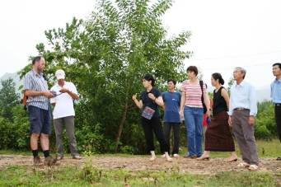
In the micro studies, DES coordinates with DECODE’s 5 thematic networks and MECO-ECOTRA human resources. DES is interested in enhancing further Skills in Documentation of Local Knowledge of 5 Thematic Issues. A strategy of how-to-do it better is to allocate 1 indigenous youth in collaborating with 1 SPERI member to co-running and co-facilitating processes of documentation, updates, and evaluation of information.

- Theme 1: sustainable organic farming practices at household and community pilots; through farm diaries, farm house profiles (for curriculum made-by farmers), database for farm houses;

- Theme 2: micro enterprises on green and ecological products at the local market (b1) for herbal medicines; (b2) for handicraft produces, (b3) for organic vegetables;

- Theme 3: preservation of local knowledge on farming practices and saving resources (effective uses of water, land rehabilitation, recycle of wastes); and documentation of local knowledge in the FFS_Simacai & Dong Le and HEPA via conduction of minority students, DES’s SPERI and volunteers; and

- Theme 4: Na Sai’s case study on applied human ecology practices e.g. traditional land use planning practices.

Assessment of DES Performance via Reviewing Monthly Highlights
Significant Events
Table 2– Reviewing the Highlights of DES works on a monthly base
Months | DES Highlights  of the Months | For inter-departments benefits
Jun - Jul, 2007 | Local Situated Knowledge | DELOBBY – DES
Jul - Aug, 2007 | Farm House Profiles and Farming Skills (Farmers-based Curriculum) | DECODE – DES
Aug- Sept, 2007 | SPERI-made teaching-by-doing training manuals as inputs for Farmers Field School | DECODE - DES
Sept-Oct, 2007 | Information Gathering of Can Ho case study | DELOBBY - DECODE - DES
Oct-Nov, 2007 | Websites SPERI Mother and SPERI daughters | BH-Media - DES
Nov-Dec, 2007 | Information Dissemination including e-library, photos, and in cooperation with SUBAVISION to make a documentary film, other references | DES - FFSs
Jan to Mar, 2008 | Systematizing the information system of SPERI (reports, e-library, photos, curriculum of FFSs, manual on herbal medicine plants and usage, and other references). | DES-FFSs
April to May, 2008 | Sharing ANU lectures with SPERI staffs; sucessefully lobby Youth ambassadors in Viet Nam (YARD) to have a research volunteer; supervising bachelor theses of students from The Vietnam Agriculture University; and transtaling AIPP materials. | DES-DEFO
Jun to Jul- 2008 | - - Field research on the traditional civil society of Black Thai in Hanh Dich commune, Que Phong district, Nghe An province;  - - Seminar workshop with RCSD, Chieng Mai Uni on traditional civil society via case of ‘Phuong Hoi’ of Black Thai in Hanh Dich commune, Que Phong district, Nghe An province | DES-FFSs and DECODE

Highlights of June - July, 2007: were the series of local situated knowledge of Hmong, Nung, and Thu Lao indigenous youths being documented. Four themes were (a) knowledge on terrace farming, (b) use and save water resources, (c) local minds of how to select land area for cultivation and reside, and (d) new house-warming ceremony. After this initiative, another series of local knowledge documentation on cultural values and customary laws practices have been successfully documented with the widest-participation of local indigenous youths.

Table 3 – 2007’s Collection of Topics on Local Knowledge (DES and FFSs, 2007)
No. | Themes of Local Situated Knowledge
1 | Indigenous knowledge in making terrace field
2 | Indigenous knowledge in selecting land for cultivation
3 | Indigenous knowledge in water management
4 | Indigenous knowledge and belief in selecting sites for making a new house
5 | Customary law and norms in traditional wedding ceremony
7 | Customary law and norms in traditional funeral ceremony
8 | Studies on ‘Nao Long’ -customary law of Hmong
9 | Studies of the role of clan heads of Hmong in local governance
10 | Belief of Hmong in worshiping the chickens
11 | Studies on traditional new years of Hmong
12 | Studies on clan ceremony of worshipping the ancestor
13 | Studies on the role of spiritual leaders of Hmong in the community life

A series of sub-questions of each theme were brainstormed and. Questions were allocated to each student of K5A class in the Farmer Field School in Simacai district, Lao Cai province – up north Vietnam. Students were asked to give answers in accordance to each personal way of understanding and free-style of answering. They were free to discuss with classmates and their family members. Compilation of all students’ answers have been going through an edition of a DES fellow; and finally, published in the Literature Magazine.

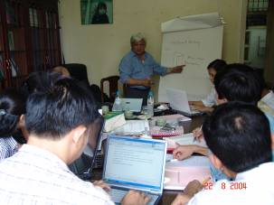
DES sees the importance of these series of local situated knowledge in relation to the function of Development Studies at SPERI. Local knowledge (of the Hmong, Nung, Thu Lao, and later Thai, Ma Lieng, Tay, and San Dui indigenous groups) is and will be a powerful means for defining and re-defining local strategies and marketing. Facilitating a group of indigenous youths sharing their views means that DES is attempting in incorporating the latest thinking (of the youths) on possible perspectives of healthy competitiveness and sustainable development for the local community at the local scale.

In the process of organizational reform, SPERI is partnering with MECO-ECOTRA members including youths. Once DES has accesses to youth perspectives, these are the preparatory steps to learn and later promoting interactive, rich in content and unrivalled decision making tools of young indigenous leaderships.

Highlights of July - August, 2007: were 10 documents of Farm House Profiles and specific Farming Skills of each Farm House being documented.

Table 4 – Documentation on Farm House Data [DES and DECODE, 2007)
No. | Names of Farm House | Provincial FFS
1 | Farm of Mr. Nguyen Dinh Thuyet, the farm owner | FFS_HEPA
2 | Farm of Mr. Nguyen Nhat Tien, the farm owner | FFS_HEPA
3 | Farm of Mrs. Nguyen Thi Hieu, the farm owner | FFS_HEPA
4 | Farm of Mr. Nguyen Van Hoi, the farm owner | FFS_HEPA
5 | Farm of Mr. Hoang Huu Phuoc, the farm owner | FFS_Quang Binh
6 | Farm of Mr. Pham Hung Son, the farm owner | FFS_Quang Binh
7 | Farm of Mr. Pham Xuan Mien, the farm owner | FFS_Quang Binh
8 | Farm of Mr. Tran Dinh Minh, the farm owner | FFS_Quang Binh
9 | Farm of Mrs. Nguyen Thi Binh, the farm owner | FFS_Quang Binh
10 | Farm of Mr. Pham Dinh Mon, the farm owner | FFS_Quang Binh

The reason for DES to build an interest in this was an aim to cultivate an initial seriousness (particularly in attitude) among MECO-ECOTRA farmers of the need to document their agricultural products in every possible step and practice. The ASEAN_GAP (Good Agricultural Practice) in its Interpretive Guide on Produce Quality Module has strongly emphasized at the produce quality which can be enhanced with farmers’ every-day’s documentation. One way to demonstrate qualitative approach for agricultural crops in the certification processes (i.e. produces are or are not organically produced) is a must-be proven process of recording, systematic and consistent produce information and farmhouse data profiles. See reference in the below Table.

Table 5 - A quality plan contains the following information (Interpretive Guide to ASEAN GAP Produce Quality Module, draft 01/11/06, page 13)
Process steps | What steps are involved in growing, harvesting and post-harvest handling?
Quality hazards | What quality loss can happen if something goes wrong during the process?
Causes of quality loss | What can go wrong during the process to cause the quality loss?
Good agricultural practices | What control measures, monitoring activities and record keeping are needed to prevent or minimize the risk of the quality hazard occurring?
As long as SPERI hands-in-hands equally with MECO-ECOTRA, DES sees its role to kick a start with this initiative; and expects to continue to facilitate other DECODE colleagues to get involved in gathering more in-depth, systematic, and consistent information on farmhouses.
Highlights of August - September, 2007: included (1) the field works to study Can Ho community herbal forest of Hmong indigenous community, Can Ho commune, Simacai district, Lao Cai province; and (2) a collection of SPERI-made teaching-by-doing training manuals; and (3) a collection of articles in database development system.
This yearly review have witnessed active involvement of DES members in collaboration with DECODE members to build up teaching and training curriculum that based upon SPERI experiences and will attempt in the next yearly plan to integrate the different SPERI’s case studies.
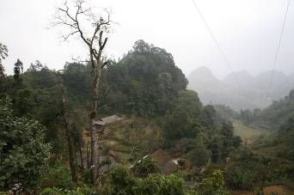
Fieldworks to study Can Ho community herbal forest were intensive. A collective teamwork has been coordinating among Hmong minority elders, members of DES, SPERI field staff, and Hmong youths. The 1st draft got into its Hmong language version of 14 pages. Issues and discussions about Can Ho community herbal forest were raised from village elders, integrated as lessons learnt in the K5A class, and among DES-DECODE-DELOBBY members.
By applied learning-by-doing and teaching-by-learning methodologies, almost all lectures have been built from the field work bases and actual case studies. SPERI’s experiences and case-based knowledge have been encouraged to put up in the similar power point format with 2 logos in the headings (1) SPERI on the left corner, and (2) MECO-ECOTRA on the right corner; that reflect an attempt of consistency. In all presentations, DES encourages all members to integrate a slide of Questions and Answers at the ending part so that allows audience after receiving information can engage into Discussion Forum whereby exchanges of in-depth views and knowledge on the topic between receivers and presenters can be promoted.
Highlights of September - October , 2007: included systematic and chronological information gathering of the Can Ho community herbal forest case. The current filing for Can Ho consists of 5 different folders: (a) back up of pro-community legal documents; (b) back up of field findings, group discussions, and individual field reports; (c) photos filing; (d) DVD on Can Ho forest and comparative cases (e.g. community forests in Bat Xat, Son Kim forestry cooperative); and (e) research training and advices (from scholars of ANU and RCSD).
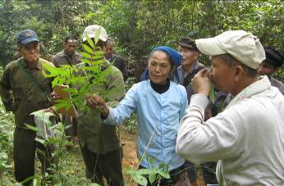
Highlights of October - November, 2007: the month signified much of DES’s involvement with international workshops and conferences; and the set-up of consistent websites system (1 SPERI mother site, and 5 SPERI daughter sites) and partnering websites (e.g. http://mekongdmp.net, http://codeinter.org)
Being exposed and kept in touch with international issues at workshops and conferences is crucial for a Development Studies Department such as DES. Not only DES itself needs updates of development concerns and learns about future trends; but also it is important for DES to build networks of scholars and activists who share similar issues of interests with DES.
DES got involved in learning Indigenous Peoples Rights and related topics by mid-August through Elder Cao Dung (Ma Lieng minority person) and Mr. Pham Van Dung (DES member)’s participation in the 3rd RNIP international conference in Ba Be National Park. DES sent people to participate in the Dams - Mining - Plantations conference in Chiang Mai, Thailand in late September to early October and much of exposures relate to large-scale development projects and associated social and environmental impacts. Three other international involvements of DES in November included (1) discussions at the Roundtable on Sustainable Palm Oil 5th in Malaysia [addressing issues of the necessity of palm oil to be certified sustainably for later bio-fuel option and other by-products]; (2) Gross National Happiness conference in Nong Khai province and Chulalongkorn University which looks at an alternative world-scale strategy i.e. the global economy should shift away from GDP values; instead should be GNH-values and practices. GNH (Gross National Happiness) initially started from Bhutan and spread through Thailand and has been followed by Canada. DES sees the interlinks between GNH as a concept agreed at international and national level and SPERI_FFSs’ on-ground practices (inc. organic farming, sustainable agriculture, living with nature, ecological farming, healthy medicines, alternative education, and community living).
The setting-up of SPERI mother site and 5 daughter sites has been the key strategy in the DES’s long term plan on upgrading information and database development system. The SPERI mother site is thought to be more focusing on professional administration works of all SPERI departments and personnel. Most of the resources allocation, information dissemination from the headquarter, research studies announcements, research grants would be the main information streams that come out of SPERI Mother site (www.speri.org). In supporting of the www.speri.org there are 5 SPERI daughter sites and each will be specializing in certain topic:
- www.dolame.speri.org -> land use issues, land rights
- www.sonkimfc.speri.org -> community forests, forestry cooperative model
- www.lobby.speri.org -> lobbying as the means and processes
- www.farmersfieldschool.speri.org -> farmers field school initiative, local situated knowledge, local innovative practices
- www.mecoecotra.speri.org -> ecological trading of eco-products
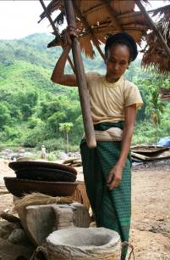
Highlights of November - December, 2007: much of the works have been focusing on information dissemination and distribution to FFS at different field sites. DES is very keen on a strategy of decentralization of information access (meaning that, access to information should (or must) be available to every one who works at SPERI including farmers and FFSs’ students. At the moment, besides a strong investment to series of systematic and consistent SPERI sites; a strategic framework on database/information development system of which including information sharing, information usage, and information management, and associated rules need to be discussed in details. Moreover, SPERI’s DES in collaboration with SUBAVISION to make a documentary film of TEW/CHESH/CIRD (e.g. in FFS_Quang Binh, Malieng people in Ke village, Lam Hoa commune, Tuyen Hoa district, Quang Binh province; Black Thai people in Na Sai village, Hanh Dich commune, Que Phong district, Nghe An provine, and Lao Lum, Kho Mu and Hmong in Luang Prabang province, Laos). The draft version for this documentary film is already completed and soon to be issued.
Highlights of January - March, 2008: to be continued the previous months that was upgrading available information of SPERI into the established systems (e.g. E-library, websites, VCD, etc). This aims to create an open information system for staff members as well as SPERI’s partners to access and use. Another task of DES during this time was editing 500 pages of data /information collected by members of the Lao-Viet Traditional Cultural Herbal Network (L-VTHEN) with the purpose to develop a manual or guidebook on herbal plants and usage. This guidebook will be basic information for further studies and used in Farmer Field Schools (FFSs) to train minority youths. Co-research is a focal of SPERI’s DES in the reforming process. So that, DES collaborated with Center for Cultural Identity and Natural Resource Management (CIRUM) to carry out action studies on land and forest conflicts in Huu Lung district, Lang Son province, Vietnam. This study is the first pilot for both sides in order to develop further cases between CIRUM and SPERI on land and forest in Central Highland, Vietnam and Luang Prabang province, Laos.
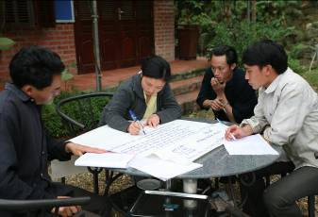
Highlights of April to May, 2008: much of the works have been focusing on carrying out cooperation SPERI’s partners (e.g. Asia Indigenous People Pacts (AIPP) for translating materials related to indigenous people and accessing to e-lectures of ANU to find out suitable documents to share with DECODE and FFSs e.g. human ecology, sustainable organic farming, community based forest, etc). Looking for the long term research partners is one of the main tasks of DES in order to meet with needs of MECO-ECOTRA as well as other SPERI’s department, especially DECODE and FFSs. In collaboration with DEFO, DES successfully lobbied the Australian Embassy to agree to assign on volunteer researcher (Mr. Mark Andrew) from Youth Ambassadors (YARD) to conduct soil research in HEPA. YARD would open a new direction for the future research cooperation. Moreover, DES started to supervise two students (Ms. Yen and Ms. Thu) from The Vietnam Agriculture Uni. to carry theses research in FFS_Dong Le, Quang Binh province and Na Sai village, Hanh Dich commune, Nghe An province. This is the way of DES which ‘invests’ in researcher resources in the future. Currently, Ms. Thu is a teaching assistant in Farmer Field School in HEPA, Son Kim I commune, Huong Son district, Ha Tinh province-Central Vietnam.
Highlights of June to July, 2008: Includes a) field studies of DES staffs and b) seminar workshop with RCSD, Chieng Mai Uni and SPERI staffs on the case of traditional civil society of Black Thai in Hanh Dich commune, Que Phong district, Nghe An province - Central Vietnam.
For the case study, DES staff closely with Black Thai elders to record ‘local stories’ and ‘local histories’ related to their traditional civil society. As results, four main research reports, around 120 pages were produced and published in the Literature Magazine, a National Magazine. Findings of the field studies were also shared with RCSD, Chieng Mai Uni (e.g. Prof, Dr. Chayan, Dr. Komatra, Dr. Malee, etc) by a seminar workshop in Hanoi.

Analysis of Significant Trends in DES as a department
Yearly Review of Performance For DES

More Independent
The need of becoming more independent is clear. Independence means to promote the pro-active approach towards learning and applied researching. Development means changing; and that, it would be under-developed for SPERI and therefore DES if DES members continued to practice the habits: sitting-at-office and/or wait-and-listen. Then, findings of the research are not piled in library, but critical issues for further theoretical researches and policy recommendations, as well application for practical training in FFSs. These habits will have to be improved. The yearly reforming sees some degrees of changes among DES members in getting involved more in the field works to learn local knowledge, gather field-data, and being exposed to new knowledge in international workshops.
Being more independent, in financial term, means that DES members need to be active to search for grants and/or funding from external sources so that supports for their own traveling and research studies. In the meantime, there is only DES coordinator who is capable to apply for funds so that paying for international field studies. Less uses of SPERI financial resources for research studies would be a sensible direction to promote more independence among DES-long-experienced members in the future. Most DES members are far too capable (given expertise and experiences built on over the years); it is therefore a strong move towards further independence will be a key strategy for DES in the next yearly plan.

More self-management
Most of DES members should become more self-managed of their plan, tasks, and time allocation. DES receives in-time all individual reports on a monthly base and this is a minor indicator. Continued practicing self-management of plans, tasks, research frameworks, efficient time uses and allocation will be sustainable for any member; and this contributes to each personal development. This is another key message that DES strongly stresses to all members to put into practices.

More professional
In the market economy, owning a capacity for any one (including DES) to well-perform tasks and addressing any development issues at the professional level - meeting the needs of multi-stakeholders as well as social actors are the most key priority in human resources development orientation at DES.
Members at DES are required to put in all efforts of implementing (a) well-perform research tasks (make good combination of quantitative and qualitative approaches); (b) be objective when analyzing development issues; (c) research findings need to be communicated and disseminated at inter-connected local-regional-national levels; and (d) be smart in accommodating “global thinking - local actions” whilst be powerful and convincing in re-drawing the localization in many senses.
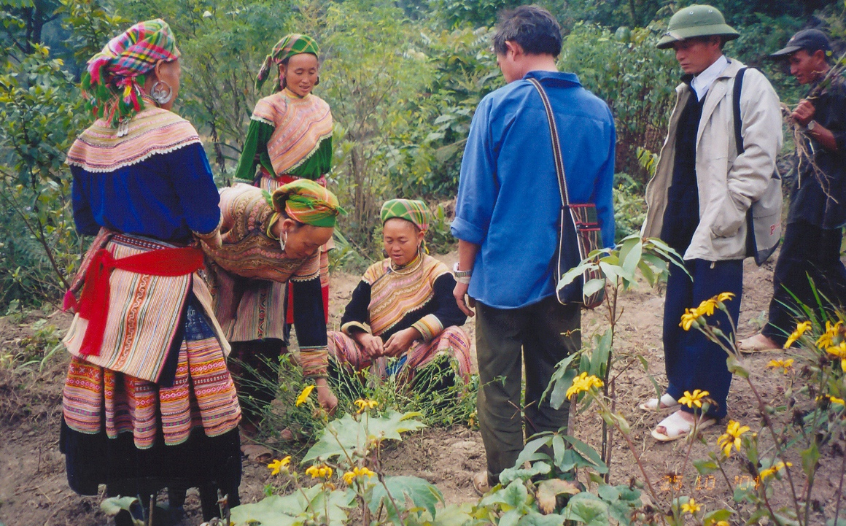
Finally, members at DES are expected to share intensive and extensive inputs of their fields of expertise and knowledge to Farmers Field School systems (i.e. every member has to make their own training curriculum, integrating SPERI case studies, and being able to deliver at easy - understandable - simple - convincing languages with the widest range of audiences as possible).

More cooperation and linking
Research issues of DES are the practical emergences of The MECO-ECOTRA and DECODE, especially Farmer Field Schools (FFSs). From then, the research topics are co-identified and carried out by these above stakeholders. Every single of new appearances from the practice updated by DECODE is shared with DES for the further discussion. This is a process of the on-going research as community development - action research - practical training - theoretical updates and policy recommendation.
Not only so, DES has looked for key academic organizations such as ANU, RCDS-Chieng Mai Uni, CRES, etc to offer research environment for its staffs, DECODE and MECO-ECOTRA to improve their knowledge and skills. The research findings are also shared with some Vietnamese political research organizations like Ho Chi Minh Academy of Thought, policy bodies such as Policy Department of the Vietnamese National Assembly. With the purpose of raising public awareness on the issues of minorities, DES has closely cooperated with some National Magazines to publish its findings for sharing.
In order to getting more cooperation, it requires DES to be more skillful in terms of visionary, strategic and inter-disciplinary coordination.

More publication and effective
For one year, in cooperation with Literature Magazine, the National Magazine DES has published 12 volumes of researches’ findings and SPERI’s approaches with the total 50,000 copies on Environmental Policy and Community Development (ECODE). Each volume referring a specific issue has from 4,200 to 4,300 copies to be distributed nationwide (see the table 6).
Table 6: Monthly publication on ECODE (DES’s 2008 report)
Months | Topics | Number of volume
Jul - Oct, 2007 | The Famer Field School in Nan San commune, Simacai district, Lao Cai province - Northern Vietnam  - - Methodology introduction and collection of minority students on customary law and cultural identities of Hmong, Nung and Thu Lao (e.g. selecting sites for making a new house, terrace fields and water management.  - - Collection of minority students on customary law and norms of Hmong, Nung and Thu Lao on wedding ceremony  - - Collection of minority students on customary law and norms of Hmong, Nung and Thu Lao on funeral ceremony  - - Discussion on teaching methodology and results of FFS-Nan San in training minority youths. | 4
Nov 2007 to Feb 2008 | Value and practices of the traditional herbal medicines  - - The traditional herbal medicine network and fair trade strategy of MECO-ECOTRA: development of the healers network of Black Thai and Hmong in Nghe An and Lao Cai.  - - Herbal plants and methodology in community development: view of points, effectiveness and impacts of the healer network strategy  - - The Lao-Vietnam Traditional Cultural Herbal Medicine Network: Situation of herbal medicine resources, indigenous herbal knowledge and strategy in the establishment of community herbal forests (CHFs).  - - The community herbal medicine a strategy to cultural biodiversity preservation in Mekong region. | 4
Mar - April, 2008 | The Famer Field School in Human Ecology Preservation Area (HEPA), Son Kim I commune, Huong Son district, Ha Tinh province - Central Vietnam  - An introduction of the philosophy of HEPA and FFS with the student-centered methodology  - An introduction of the methodology of practical training courses on ecological farming system for minority youths of Laos and Vietnam. | 2
May-Jun, 2008 | Land Ownership and Minority Existence - the philosophy of SPERI  - - The interactive relationships between land and existence, vision of SPERI on ecological farming system and failure of the government in land use planning.  - - The quality of society via analysis of the practice of people ownership to land which is mentioned in land law | 2
The first prioritized audiences of the ECODE are members of MECO-ECOTRA, students in FFSs, SPERI’s staffs and SPERI’s partners in Laos and Vietnam. Regularly audiences of the ECODE are minority students in the government schools, departments of culture and telecommunication of all mountainous provinces, provincial departments of Education, Culture and Art Associations of mountainous provinces, post offices at commune levels, free writers and authorities and policy makers, etc.
The ECODE are monthly shared with central governmental offices for instance, The Secretariat of the Party Central Committee, The Propaganda and Instruction of Party Central Committee, The Council for Minority of the National Assembly, The Government Office, The Central Minority Committee of the Government, Ministry of Finance, Ministry of Culture, Tourism and Sport, Ministry of Information and Communication, Vietnam Association of Writers. Some individual progressive authorities and policy makers are interested in the ECODE. They are also monthly receiving the ECODE as references for the policy discussion agenda.
All articles and publications of DES are moreover published in SPERI’s webs and internal magazine, so-called The ‘Sinh Ton’ - The Existence. Hundreds of articles and news are regularly updated, and mostly shared with members of MECO-ECOTRA, minority students in FFSs, SPERI’s staffs and SPERI’s partners in Laos and Vietnam.

Australian National University (ANU, Australia)
DES and Research and Publication Partners

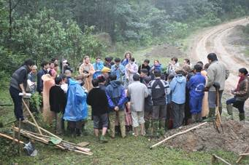
The Australian National University (ANU) would be a long-term research and education cooperation in term of several following aspects.
By nature, it has been through SPERI’s staffs (Mrs. Tu Kien, an ex-student from ANU) who keeps regular touch with students and lecturers from ANU. ANU is most strong at theoretical and analytical frameworks majoring in geography and environmental management fields.
There is not yet a shared environment in which SPERI and ANU representatives sit down together to discuss about shared issues of interests. And that, the contact persons from ANU are not authorized to sign a formal MOU with SPERI. Lecturers and students from ANU who made visits to SPERI have been informal.
Three levels of informal cooperation being defined such as: a) Lecturers (ANU: share Australian experiences) and senior DES members (SPERI: share SPERI experiences). Form of relationship could be as a process of facilitation / supervision for junior and applied researchers (or research assistant); Shared issues of concerns - geography (development geography, human geography, political geography); and applied case on community rights to land and forestland – Can Ho commune, Simacai district, Lao Cai province. Students of ANU assist and help with English and also new knowledge and interaction with minority students in the networks of Farmers Field Schools (FFSs).
Form of relationship as cross-cultural learning processes, it could share issues of interests (e.g. English, FFS experiences, Australian Aboriginal youths, Geography and the Environment, education system (quantity and quality approach).

Permaculture Research Institute (PRI) - Australia

The Permaculture Research Institute (PRI), a practical based research organization is seen as a long-term partner of SPERI in term of providing training and research on ecological farming system, landscape design. This cooperation is directly serving members of the ecological farming network of MECO-ECOTRA and minority students in FFSs. So that, they could get more critical thinking of farm designing and soil improvement in sustainable ways. PRI moreover introduces its perma’s network members to be volunteer sources for SPERI whether are practical researchers or practitioners in permaculture.

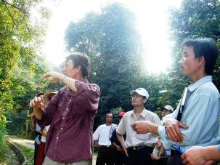
Regional Center on Sustainable Development (RCSD), Chieng Mai Uni- Thailand)

The cooperation with the Regional Center on Sustainable Development (RCSD) offers academic environment to enhance analytical thinking and research writing skills for senior staff; at the same time, training of trainer or new research trainings should be designed for junior and field staffs. RCSD also would offer PhD, MA and Diploma courses for SPERI’s staff. Besides, RCSD gets more practical facts / experiences from case studies of DES in order to update into theories and lectures for students in Chieng Mai Uni.
Due to the close interaction between RCSD and Chieng Mai Uni which is a well-known academic organization located in Mekong region and train mostly students from Mekong countries, so that this cooperation is expected to be long-term.

The Faculty of Culture, Minority and Religion (FAMIRE), Ho Chi Minh Political Academy
The Faculty of Culture, Minority and Religion (FAMIRE) is a strategic partner of SPERI in research and development. FAMIRE is a ‘governmental think-tank’ to recommend for the government policies. This institute mostly provides academic and theoretical environment for students who are authorities and government staffs from commune to provincial levels. So, the cooperation with FAMIRE means looking for progressive authorities and governmental staffs for further cooperation when they graduated and went back with their positions. SPERI realizes that this is a ‘niche’ approach in term of lobbying.
Besides, FAMIRE has been teaching for over 30 years only focusing on old theories of Socialism, Marxism and Leninism, but forgetting the ‘other side’ of the world as capitalism (e.g. development theory, liberalism, neo-liberalism, etc). So, by this cooperation, FAMIRE would have more opportunities to contact with SPERI’s partners who have holistic views on minority, culture, religion and development.
Moreover, SPERI will provide practical evidences, practical approaches which FAMIRE has been looking for. This is not only meaningful to FAMIRE’s teachers, but also for students in order to update into the lectures and training courses.

Centre for Natural Resources and Environment Studies (CRES), Hanoi National University
Centre for Natural Resources and Environmental Studies (CRES), a national research organization is also seen as long-term cooperative strategy of DES in several aspects.
First, CRES could share information resources, e.g. sustainable organic farming, forest and water management, for SPERI’s staffs, MECO-ECOTRA and minority students in FFSs. Second, this center also provides some short-courses training on research methodologies for SPERI’s staffs. Two staffs of SPERI were being trained for the six month course on research methodology provided by CRES. After training, these two staffs get more knowledge on research and are confident to work on research and training in FFSs.
In return, SPERI would provide practical environment for CRES’s staffs and students who are local authorities and staffs to have critical views on environment, society and development, esp. in the sensitive highland areas where minorities live. For instance, FFSs in HEPA - Ha Tinh province and Dong Le , Quang Binh province - Central Vietnam hosted several field visits for CRES’s staffs and partners to study and exchange on natural preservation and development.

Institute of Social Entrepreneurship in Asia (ISEA)
ISEA’s objectives are to build an action and learning network among social entrepreneurs, social enterprises and social enterprise resource institutions in Asia to promote exchange of experiences and expertise, create greater awareness and access to existing resources supportive to social entrepreneurs and enterprises, catalyze the spread of social entrepreneurship in the region, facilitate the building of support mechanisms and platforms for cooperation with other sectors, catalyze joint action to create a favorable environment for social entrepreneurship.
SPERI’s DES has been cooperated with ISEA via several internal workshops on social entrepreneurship in Philippines and field visits to micro-enterprises which are advised by SPERI in Quang Binh province - Central Vietnam. In the cooperation frame in research and development, both sides SPERI and ISEA agreed to organize a regional training course on case study writing on social entrepreneurship in Vietnam in 2009.
In the long-term, ISEA would provide practical and research environment for both SPERI’s staff, members of MECO-ECOTRA to improve skills and knowledge in social entrepreneurship development, as well have more contacts and sharing with organizations who have the same vision and concerns in Asian region.

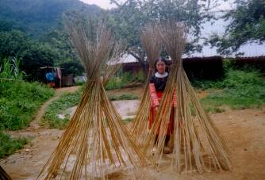
The Literature Magazine (Bao van nghe Dan toc)
The Literature Magazine is a strategic partner of SPERI’s DES in publication for the purpose of information dissemination and raising awareness of the public about concerns of indigenous minorities in Vietnam. Over the two years cooperation, the Magazine has created more public opinions related to policies of minorities and their identities and livelihood resources (land, forest). Moreover, articles in the Magazine which refer to voices and images of minorities enter into political and academic institutes / Uni. (e.g. Ho Chi Minh Academy of Thought, National Culture Uni., etc), and on desks of the central governmental officers and legislators. In the future, SPERI’s DES would like to lobby the Magazine to become a public forum of indigenous minorities not only in Vietnam, but whole Mekong region.

The Vietnam National Broadcast (VTV2)
A pilot program on multi-media between the Vietnam National Broadcast (VTV2) and SPERI’s DES has been set up in the period from 2008 to 2010. This cooperation would open new direction for the strategy of public awareness raising in which DES’s research findings, voices and images of the locals, indigenous youths, elders and minority women will be broadcasted nation-wide. By this way, DES’s expectation is to support more DELOBBY for its lobby strategy via local stories, local images, local histories and local alternatives in the mainstream thinking and development.

Table 1: Diagram the inter-relationships between SPERI and ANU

Lecturers  Students (inc. undergrad, postgrad,  Voluntary and intern students  ANU | Geog lecs  Field work - methodology (e.g. minor research studies)  Cross cultural learning and shared experiences (e.g. English, hands-on, farm stays)  SHARED ISSUES | Senior staff  Junior staff (inc. field staff and EM students)  Voluntary and internships  SPERI

Key Findings
- Case study on Community Herbal Forest of Hmong people in Can Ho Commune, Simacai district, Lao Cai province - North of Vietnam.
There are 3 significant findings:
The first is, ‘community’ forest in Can Ho has not been officially certified with Land Use Rights Certificate; yet, been well protected by collective management of between Ta Can Ho village members and the group of 13 Hmong minority herbalists. Both villagers and herbalists have applied strong community traditions (inc. customary laws and regulations) to manage the common forest.
The second is, in the Communal Land Use Planning of Can Ho People’s Committee, we are informed that 48 hectares of the total land areas in Can Ho commune have been allocated for ‘landscapes’ forest but not ‘community’ forest; it is therefore a need to do an in-depth learning of the differences between ‘community’ forest [from local point of view] and ‘landscape’ forest [from official point of view].
The third is, Can Ho community herbal forest has been well co-managed by a combination of Hmong customary regulations and traditional mode of management of the Hoang clan. 9 generations of the Hoang clan have been involved in protecting the forest. Can Ho herbal forest have recently been extended to 13 herbalists of multi-clan groups in and near Can Ho commune by April 2006. Given a strong shared-commitment between herbalists and villagers, a sound co-management model for multi-social actors to protect this common forest should be further studied and discussed.
- Case study on Transforming Civil Society: Traditional Civil Society of Black Thai in Hanh Dich Commune, Que Phong District, Nghe An Province - Central Vietnam.
There are 3 significant findings:
The fist is, the traditional civil society in general, with the case of Black Thai in Hanh Dich is still a new concept, not well recognized by society at large; so that it needs to be further studied and discussed. In general, this concept must be identified and conceptualized by the locals; so that it is understood in accordance with the specific geo-cultural identity groups.
The second is, the traditional civil society of Black Thai characterizes the voluntary spirit and strong shared-commitment among villagers and interest groups, so-called in Thai Language ‘Phuong Hoi’ (e.g. ‘phuong cay gat’ - agriculture production, ‘phuong lam nha’ - making a new house, ‘phuong dam ma’ - funeral and ‘phuong dam cuoi’ - wedding) in local community governance, natural resource management and maintenance the indigenous values. Moreover, this concept implies the meaning and practices of indigenous religion, norm and social traditional structure.
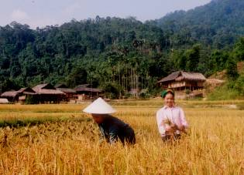
The third is, the traditional civil society of Black Thai is being transformed into the model society. This is as a consequence of several causes. First, new road of the government has brought more and more modern lifestyles to villagers, especially youths (e.g. consumerism, individualism which cases damage of the community spirit, traditional structure and values). Second, there is a tendency of business companies to take over natural resources (land and forest) which is seen as the main source for nurturing Black Thai traditional religion, norms and structure. Third, strong imposition of the government criteria on civilized society civilized village and civilized culture to Black Thai community. This causes an assimilation of the traditional identity and rapid fragile of the traditional civil society of Black Thai people which has been practicing for hundreds of the year via the ‘Phuong Hoi’ values.
Therefore, network methodology (e.g. among and between identity groups and across border countries) would be an important strategy to offer more environment and conditions for the minority civil society like Black Thai to recognize their strengths, weakness, potentials and challenges, and find out alternatives for their own sustainable development.
- The case of sustainable organic farming practices at household and community pilots; through farm diaries, farm house profiles (for curriculum made-by farmers), and database for farm houses.
There are 3 significant findings:
The first is minority groups who are living in remote areas still maintain well and practice the local knowledge and skills in farming. However, the tendency is that these local adaptive knowledge which mainly serve for subsistent economy are struggling with the modern techniques, hybrid species and overused of chemicals that are demands of the mono or industrialized agriculture.
The second is, the farm diaries or farm house profiles are very new to small-scale Vietnamese farmers, especially minorities. However, with the aim to harmonize preservation and development, particularly in the time of globalization and WTO with high demand for trademarks, quality of products, etc small-scale farmers would be equipped of these basic tasks.
Therefore, role of minority youths who are studying in Farmer Field Schools (FFSs) or the function of FFSs is important in the process of preservation and development of farming practices. After finishing studies, they could assist their parents in term of bring more critical thinking for sustainable organic farming practices.

- Micro enterprises on green and ecological products at the local market (b1) for herbal medicines; (b2) for handicraft produces, (b3) for organic vegetables.
There are 4 significant findings:
The first is, in the same situation with farming practices, minority groups who are living in remote areas still maintain well and practice the local knowledge on herbal medicine and traditional handicrafts. However, the tendency is that this local adaptive knowledge which mainly serves subsistent economy are struggling with the industrialized products that are demands of the modern and consumerism society.
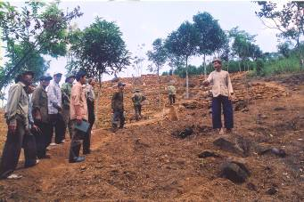
The second is, the concept of market, trading of ecological products (e.g. organic vegetables, handicrafts and herbal medicines) are still new to minorities, especially those who are living in remote areas. As they still practice the independent economic system which significantly serve the spirit of self-help, sharing and community atmosphere. Hence, the question is that how to balance the social values, ecological and economic capital, and in what context?
The third is, the research finding is that in order to support micro-enterprises and ecological products, it requires development organizations several attentions: a) capacity building for the farmers on skills on family/social enterprise management (e.g. recording indigenous knowledge, diaries, social business planning and marketing, etc); b) networking or association among small-scale producers or enterprises to get more bargaining power; c) linking small-scale producers with researchers, authorities and social responsible business organizations; d) local markets are sill priority at the moment which help farmer-producers to practice above skills and ability while it is still serving for social-ecological values.
The fourth is, role and function of Farmer Field Schools (FFSs) and SPERI’s DES are important to support small-scale farmer producers to be confident with with own business.

- Preservation of local knowledge on farming practices and saving resources (effective uses of water, land rehabilitation, recycle of wastes); and documentation of local knowledge in the FFS_Simacai & Dong Le and HEPA via conduction of minority students, elders and DES’s SPERI.
The researcher composition of one indigenous youths, one elder and one DES’s staff or volunteer play a important role in promotion of the inter-disciplinary, inter-culture, inter-generation and inter-geography of knowledge preservation and generation. These action researches would be a basic for point 1, 2, 3, 4 above. Moreover, they will provide the practical evidences and thoughts for SPERI’s DELOBBY to lobby the government in term of indigenous right to land, forest and water, sustainable land use planning, sustainable economic development, and social and political engagement.

In the next coming years (2008 to 2010), strategic themes bellowing will be focal points of SPERI’s DES for studies.
Coming Themes for Studies

- Continuity with three macro-level case studies (e.g. Community forest in Can Ho commune, Simacai district, Lao Cai province, civil society transformation: case of Black Thai in Hanh Dich commune, Que Phong district, Nghe An province, and conflict transformation in Long Lan village, Luang Prabang province, Laos. These cases will be upgraded into the theoretical research and policy application. These researches will be done via cooperation with SPERI’s research partners (e.g. ANU, RCSD).

- Local governance of minorities and grassroots democracy, indigenous knowledge – health care system and poverty alleviation, and matriarchy system of Mnong and Ede in Central Highland, Vietnam. These two themes will be done through cooperation with the Faculty of Minority, Culture and Religion, The Ho Chi Minh Political Academy.

- Local stories and local history for recording indigenous knowledge in ecological farming, landscape designs, herbal medicine and handicraft; customary law in community forest management. This would be mainly done by minority youths in FFSs and elders, members of MECO-ECOTRA and CRES - Hanoi Uni.

- Social entrepreneurship development: Value chain analysis via cases of thematic networks of MECO-ECOTRA (e.g. ecological farming network, herbal medicinal network, traditional handicraft). This topic will be done via cooperation between DES and ISEA (Institute for Social Entrepreneurship in Asia, Philippines).

- Action research on sustainable ecological farming practices: landscape designs, soil improvement and water management, non-pesticide pet management, recyle energy, etc. These themes will be done by famers, students in FFSs in cooperation with PRI.

- Multi-media program with the Vietnam National Broadcast Tivi (VTV2) with the aim to broadcast voices and images of minorities to get public awareness and opinion, public about all above topics. This is seen as a channel to promote democracy via public political engagement in Vietnamese society.

References

- The six-monthly reviews of DES: July to December 2007 & January to June 2008 - (DES-SPERI’s progress reports, 2007).

- The DES’s staff monthly reports: July 2007 to June 2008 (DES-SPERI’s progress reports, 2007-2008).

- The DECODE’s yearly report: July 2007- June 2008 (DECODE-SPERI’s progress report, 2007-2008)

- The DEFO’s yearly report: July 2007- June 2008 (DEFO-SPERI’s progress report, 2007-2008)

SPERI is a successor organization of the three sister-organizations Towards Ethnic Women (TEW); Center for Human Ecology Studies of Highlands (CHESH); and Center for Indigenous Knowledge Research and Development (CIRD).
ANU, ISEA, RDSC-Chieng Mai Uni. Ho Chi Minh Academy of Thought, CRES of Hanoi National Uni.
Traditional civil society via ‘Phuong Hoi’ of Black Thai people in Hanh Dich commune, Que Phong District, Nghe an province – Central Vietnam; Traditional ‘Phuong hoi’ and Natural Resource Management in Hanh Dich commune, Que Phong district, Nghe An province, Central Vietnam; Traditional ‘Phuong hoi’ and Indigenous Religion of Black Thai in Hanh Dich commune, Que Phong district, Nghe An province, Central Vietnam, and Value of Customary law of Black Thai in Natural Resource Management in Hanh Dich commune, Que Phong district, Nghe An province, Central Vietnam
Customary law in watershed management, traditional herbal medicine, ecological farming, traditional handicraft, human-ecology village and farmer field schools
Thesis of Ms. Yen with the title: Indigenous knowledge of Black Thai in wet rice production and water management: case in Hanh Dich commune, Que Phong District, Nghe An province – project area of SPERI. Thesis of Ms. Thu with the title: Soil improvement via Integrated Alternatives in FFS_Dong Le carried out by Farmer Networks in Quang Binh province - Central Vietnam.
Mr. Hoang Vinh Bao - Head of the Department of Socio-Culture of Government, Mr. Chu Tuan Thanh, Vice-head of Propaganda Department, the Minority Committee of the Government, Mr. Hoang Duc Hau, head of Culture and Minority Department, Ministry of the Culture, Tourism and Sport, Mr. Vu Van Thao, Head of Budget, Society and Insurance Department, Ministry of Finance, Mrs. Nguyen Lan Huong, Journalist Department, Ministry of Information and Telecommunication and Mr. Nguyen The Ki, head of Journalist department, the propaganda and instruction of the party central committee
See more at http://www.anu.au
See more at: http://www.permaculture.au
See more at: http://rcsd.soc.cmu.ac.th/
See more at http://www.cres.edu.vn/

