Yearly Narrative Report
July, 07-June, 08
The yearly narrative report will review the process and its effectiveness of reaching self-management, self-accountability, more cooperation and linkage of SPERI’s DEF in the reforming.]
SOCIAL POLICY ECOLOGY RESEARCH INSTITUTE (SPERI) Department of Finance and Accounting (DEF)
1/8/2009



Acronym

SPERI: Social Policy Ecology Research Institute
DAD: Department of Administration

DEF: Department of Finance and Accounting
DEFO: Department of Foreign and Cooperation
DELOBY: Department of Lobby
DECODE: Department of Community Development
DES: Department of Development Studies
MECO-ECORA: Mekong Community Networking for Ecological Trading
TEW: Towards Ethnic Women
CIRD: Center for Indigenous Knowledge Research and Development
CHESH: Center for Human Ecology Studies of Highlands
CBO: Community Based Organizations
CBI: Community Based Institution
OD: Organizational Development
ID: Institutional Development
FFSs: Farmer Field Schools
ECODE: Environment Policy, Community Development
DEFIM: Decentralization on Financial Management
OREMA: Organizational Report System Management
EFIAS: E-management of Financial and Accounting System
STOs: Scientific Technology Organizations
TOT: Training of trainers
MOF: Ministry of Finance

Introduction

Social Policy Ecology Research Institute (SPERI) is an independent scientific technology organization (STO) which is set up under the Degree No.81/ND-CP dated on 17/10/2002 by the Vietnamese government, and the Instruction No.10/2005/TT-BKHCN on the registration formalities of setting up STOs dated on 24/08/2005. SPERI is a financial self-accountable organization which is directly regulated under the law.
The program on MECO-ECOTRA which is being following up from TEW/CHESH/CIRD started since July 2006. The emerging of TEW and CIRD to become SPERI, and SPERI’s reforming since July 2007 require changes of professional sessions (e.g. department of community development-DECODE, department of development studies-DES, department of lobby -DELOBBY, department of foreign and cooperation -DEFO, department of finance and accounting-DEF, and department of administration - DAD). The reforming has asked for every part of SPERI more professional, more self-accountable, more cooperative and linking and more self-efficient.
The period from July 2007 to June 2008 is seen as the middle term of SPERI’s DEF reforming. Therefore, DEF has prioritized the following objectives:
- To analyze and find out problems, causes of and alternatives for the mis-management in the financial and accounting system in the process of merging TEW/CHESH/CIRD into SPERI; and
- To have a suitable financial management and accounting system to meet the practical needs of SPERI’s reforming and independent STOs.
This narrative report has two main parts: Part I will review the process and effectiveness of DEF’ self-reforming. Also, the report will show some challenges and reliable recommendations on financial and accounting system of STOs like SPERI. Part II refers to the yearly organizational financial report
Indicators of DEF’s Performance

More Self-management and Self-Accountability via

Decentralization on Financial Management (DEFIM)
As an independent SPERI organization, decentralization on financial management (devotion, delegation and assignment of tasks) to all professional departments is a necessary strategy. As the result, SPERI’s staffs are now pro-active and confident to self-manage financial and accounting tasks effectively at all levels (individuals, thematic sections, departments and organization).
In order to address this process, SPERI’s DEF in collaboration with other fellow departments has established an organizational system on financial and accounting management. Heads of departments, regional program officer and thematic divisions are also required as the sub-financial managers (e.g. financial planning for six months, accounting supervision, etc). In accordance with new practical needs and the existing organizational budget they developed reliable and feasible budgeting plans to submit the SPERI’s organizational financial manager for approval.
During this time, tasks of the organizational financial manager are not very much on accounting advice and budgeting control; but the most importantly is financial analysis (e.g. effectiveness of funding, prediction of systematic risks and advising for the directorship board the financial policy and development at organizational level.
Moreover, heads of professional department and regional program officer (e.g. in Simacai-Lao Cai province, Quang Binh province and DEFO) are actively looking for additional financial sources to serve the needs of MECO-ECOTRA. In so far, they cooperate with some development organizations (e.g. Training of trainers (TOT) on organic farming for minority youths in Simacai-Lao Cai and Ha Tinh provinces), government program (e.g. governmental program No.135 and 134 for Malieng people in Quang Binh, and for minority youths who graduated from FFSs to borrow loans to develop their gardening).
SPERI’s program locations are mostly in remote areas; so that it is hard for the organizational financial manager to supervise and manage effectively financial and accounting activities. Therefore, DEF has set up an e-management system on financial and accounting. Budgeting plans of every staff, thematic division, region and department are approved via the internal email system. Money will be transferred into bank accounts managed by the regional program officers; heads of department after the plan was approved. The e-management system on finance and accounting has so far met criteria of transparency, flexibility and less bureaucracy, creating enabling environments for staffs in term of self-management and self-accountability.

More Capable Staff via Organizational Report System Management (OREMA)

In order to improve ability of staff in analyzing, writing and criticizing SPERI has set up a reporting system applied to different levels (e.g. departments for six months and individual for a month). Quality requirements in the reports relate to not only incomes (e.g. salaries, awards, etc), but the most importantly OREMA has significantly encouraged and stimulated creativeness and activeness and responsibility of every department and staff.

For instance, the report of senior staffs who work in
research and community development requires the highly analysis of outcomes, effective and impacts as well as methodologies of SPERI; difficulties, challenges and recommendations for targeted communities, other fellow departments and development policies of organization. Outcomes of this report are used for publications in the Environment Policy, Community Development (ECODE) in the Literature Magazine, SPERI’s websites, and Farmer Field Schools (FFSs), etc with the purpose of public awareness raising.

With junior staffs, quality of the report is required lower compared to the former group. The report only mentions outcomes, effective, impacts, difficulties and recommendations in areas to which they are responsible. While administrative officers only diary what has been done, and analyzing inappropriate points of the government policies related to public administration, particularly to civil society organization as SPERI.

Report of every department’s staff will be critically contributed by the department’s head and approved by the directorship board for decision of the monthly salary levels.

More Flexible and Effectiveness via E-management of Financial and Accounting System (EFIAS)
As the almost program locations of SPERI are in remote areas; so that this has caused a lot of difficulties for the financial manager to supervise effectively staffs and departments to follow the organizational financial process. Therefore, e-management of financial and accounting system (EFIAS) is a practically accepted as a strategy to deal with the above difficulty. Moreover, this system creates a transparent and flexible environment in financial management. EFIAS has several steps.

The first is, every department submits the six monthly action and budget plan which is built in accordance with the practical needs to the organizational financial manager via the internal email (staff/department@speri.org). These plans are critically supervised before approval and transferring money to the bank accounts of delegated persons (e.g. regional program officers, head of department, etc). An approval of the organizational financial manager must be based on reliable accounting reports of the previous six monthly plans, the existing budget status of organization and the new practical needs of MECO-ECOTRA.

More Financially Controllable (FICO)
FICO is a standard of SPERI which reflects capacity of DEF in advising the fellow departments and thematic sections to self-manage and coordinate their activity and financial plans. FICO aims to ensure: a) financial security, and b) address objectives/goal of organization as well as new appeared development needs in reality. In reality, DEF has well performed this tasks (see figure 1, 2, 3, 4) in which: HEVI - Human ecology village, HEN - Traditional herbal medicine, HAN, Traditional handicraft textile, ECO-FARM – Ecological farming, CUSLAW - customary law in watershed management, FFSs: Farmer Field Schools, HRD: Human resource development, R&D – Research and development, OC - Overhead costs, and M&E - Monitoring and Evaluation.
Figure 1: The percentage of the approved budget and real expenditures of organization (fiscal plan Jul, 2007-Jun, 08)
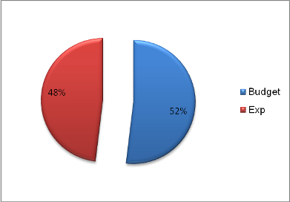

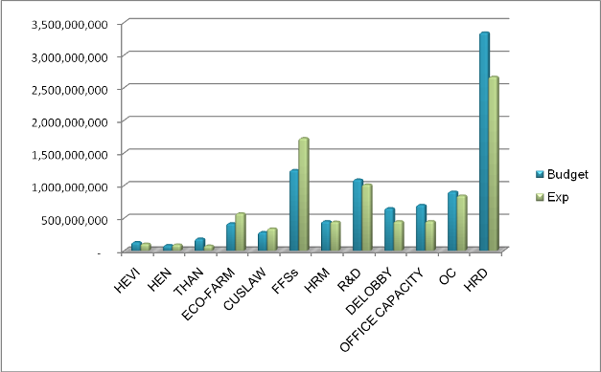
Figure 2: Comparision of the approved budget and real expenditures of different themes (fiscal plan Jul, 2007-Jun, 08)

Figure 3: The percentage of the approved budget and real expenditures of CHESH Laos program (fiscal plan Jul, 2007-Jun, 08)

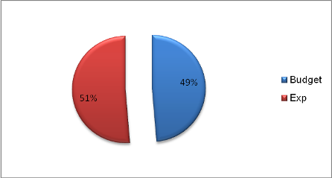

Figure 4: Comparison of the approved budget and real expenditures of different themes in CHESH Laos program (fiscal plan Jul, 2007-Jun, 08)
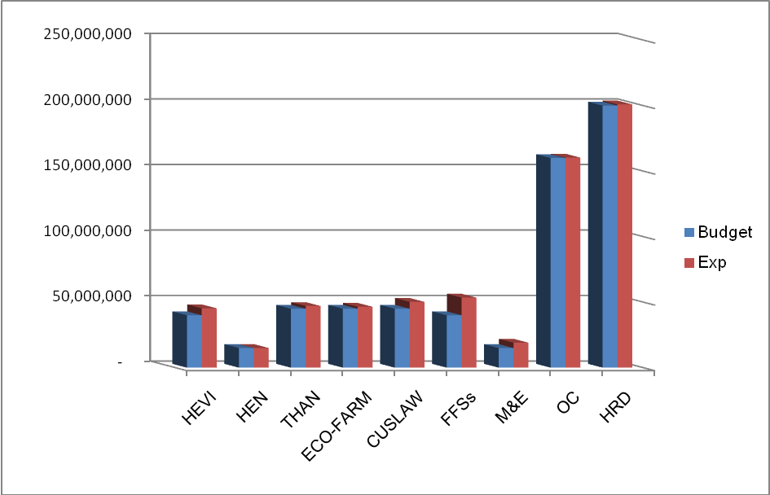

Process of DEF’s reforming

Firstly, DEF in cooperation with the fellow departments identified gaps, mis-management, causes and solutions from the previous stages (e.g. before and after merging TEW and CIRD into SPERI). Several bellowing steps, DEF has focused.
- Setting up an organization financial regulation which is suitable to an independent scientific technology organization like SPERI. The financial regulation supports spirit of self-management, self-accountability of every part of organization;
- Setting up appropriate reporting systems at all levels (e.g. individual staff, departments and organization);
- Setting up criteria for budget approval applied to the six monthly plans of departments, especially overhead expenditures not over 19%, while prioritizing for development activities (e.g. practical training in farmer field schools -FFSs, and thematic networks of MECO-ECOTRA);
- Setting up an e-management of finance and accounting which allow the financial manager and directorship board to access, supervise and approve budget plans, expenditure reports of all parts of organization flexibly and effectively.

Secondly, situation of borrowing among projects through different periods of term was the first priority needs to be solved. DEF set up a solution which based on the existing situation on budget, financial system and requirements of the new independent SPERI, and submitted to the directorship board and donor for approval. Currently, situation of borrowing money among projects is completely worked out. The balanced budgets and assets of TEW and CIRD were transferred to and managed by SPERI currently.

Thirdly, most of the SPERI’s project locations are in the very remote areas. These areas are far from one to others. While these project areas sometimes require having equipments and facilities in the same time. This makes the management of equipments and facilities difficult (e.g. repairing and improvement). DEF prioritizes to set up a suitable system for equipment and facility management and usage since February 2008. This system is applied for all SPERI’s project offices (e.g. Lao Cai, Quang Binh, Ha Tinh and Nghe An).

Fourthly, DES in collaboration with independent experts of the Ministry of Finance (MOF) established a guidebook on financial and accounting management for SPERI. DEF realizes that with an independent STO like SPERI which is directly regulated under the law, the guidebook on finance and accounting play a key role. The most importance is that this guidebook is already approved by the Ministry of Finance. It means that SPERI has to be responsible directly under the law all its activities including finance and accounting, but not under any umbrella organization (e.g. CIRD/TEW used to be under the Vietnam Union of Scientific Technology Association -VUSTA).
In the process of cooperation in setting up the guidebook, SPERI’ DEF has successfully lobbied MOF to change some articles in the Instruction No. 32/2007/TT-BTC related to VAT (value added taxation) dated on 9/4/2007 applied for Vietnamese independent scientific and technology organizations. However, in the reality this instruction is not suitable to STOs like SPERI who are receiving foreign funding (e.g. ICCO). These STOs do not need to pay VAT as they works in philanthropy. This critical point is being accepted by MOF for further discussion and approval.

Based on the guidebook, the next step is to set up software in financial and accounting management. This software would allow accountants (e.g. in Ha Noi and field programs) to manage the flow-in/out of money, as well bookkeeping effectively. This system also allows the organizational financial manager and directorship board to easily access, analyze the budget status and effectiveness of every project. Head of departments and program officers could carry out the DEFIM effectively based on supervisions of the directorship board and financial manager.

The first is, activities of SPERI characterize as research and development; so that it is hard to predict emerging expenditures in the reality in relation with new needs of target groups (e.g. thematic networks of MECO-ECOTRA). If DEF works just only bases on the existing budget of organization and agreement of the donor on finance, many emerging developmental activities in the pratice would not addressed. In return, if DEF only follows the practical emerging needs, expenditures would be not suitalbe with contents in the approved budget plan. Therefore, how SPERI’s DEF could find out the flexible and strategic financial management system to deal with this challenge.
Difficulties

The second is, the contingency of 10% for all expenditure items as mentioned the contract agreement between the donor and SPERI is sometimes hard for implementation. For instance, practical training on ecological farming via Farmer Field Schools (FFSs) in the 2006-2009 MECO-ECOTRA program was not prioritized. It means money for FFSs compared to other themes is smaller. However, during the implementation, SPERI realized that the practical training program is a key in order to address the long-term objectives of MECO-ECOTRA (as mentioned in the MECO-ECOTRA program: 2006-2015). Hence, SPERI actively re-directed its direction to FFSs since July 2007 up to date. The contingency for FFSs is about 40% compared with 10% as mentioned in the agreement.

The third is, the fact shows that the funding/money which were being used directly by the target groups such as thematic networks or community based organizations (CBOs) from MECO-ECOTRA is the most effective way. However, these CBOs are yet recognized and approved by the Vietnamese government. Therefore, there is no any legal document to allow CBOs to directly receive funding sources (e.g. foreign funds) for their community development activities.
For the first and second difficulties: how to make a balance between new appeared expenditures in relation with new needs during the program implementation and the fixed budget items approved by the donor.
Suggestions

- The financial and accounting system of SPERI must be flexible enough which could cover as much as possible new practical needs of the target group in development process. DEFIM and EFIAS are seen as solutions for that.
- Instead of 5-10% for contingency, the financial system of both the donor and SPERI should allow all departments of organization to obtain 15-25% of contingency. This amount could meet the new practical needs appeared during the program implementation;
- During this time, initiatives of the target groups, especially minority students in FFSs increase significantly. So that, it is needed to set up a ‘trust fund’ in order to encourage these above initiatives.

For the second difficulty: SPERIs’ DEF in collaboration with DELOBBY will lobby the government (e.g. National Assembly and Ministry of Finance) to issue a legal framework for community based organizations (CBOs). Then CBOs are legally recognized, they will be confident to contact directly with different funding sources in order to operate their own development activities.

- The six-monthly reviews of DEF: July to December 2007 & January to June 2008 - (DAD-SPERI’s progress reports, 2007).

- The DAD’s staff monthly reports: July 2007 to June 2008 (DES-SPERI’s progress reports, 2007-2008).

- The DECODE’s yearly report: July 2007- June 2008 (DECODE-SPERI’s progress report, 2007-2008)

- The DEFO’s yearly report: July 2007- June 2008 (DEFO-SPERI’s progress report, 2007-2008)

Reference

This report will be written in the separate document.

